Lambretta Li125 Series 2 restoration project
Purchased from Daniel Rogers in March 2020 – The ad:
LAMBRETTA ITALIAN 1960 Li125 Series 2 - Lovely old barn find this, 100% complete, did have it running last year, and was going to use as daily, but she’s slowly got buried further back in the shed, better she goes to a new home - ride as is or restore. Anyone seriously interested please PM too discuss price and delivery.
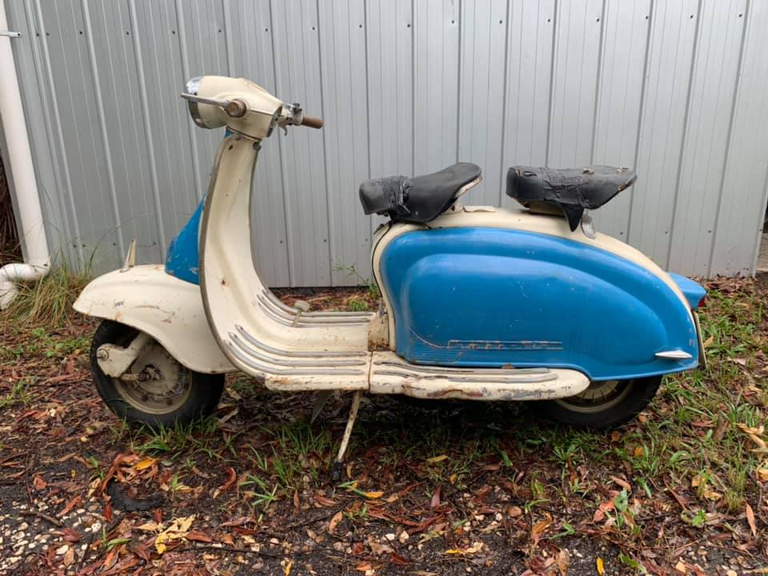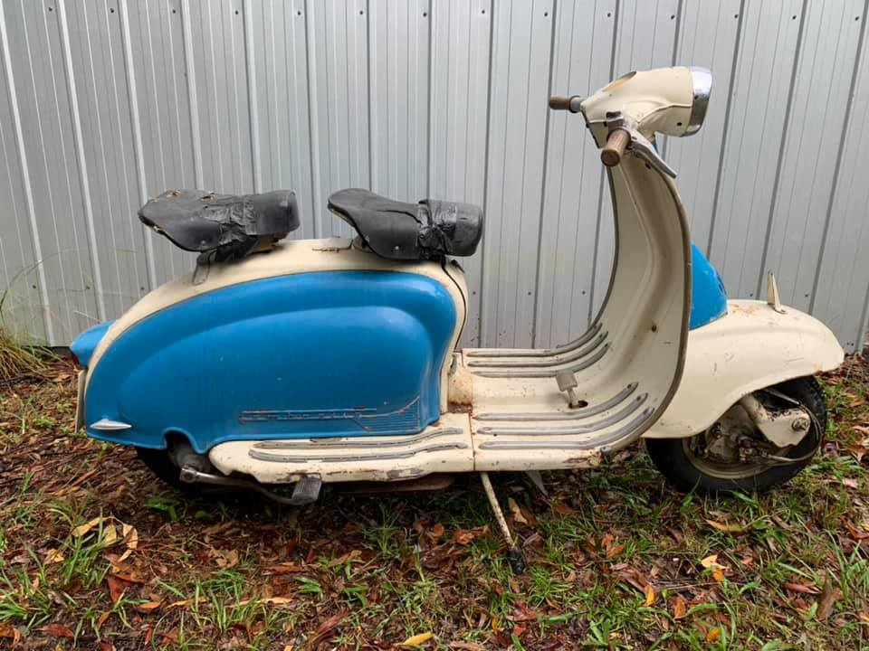
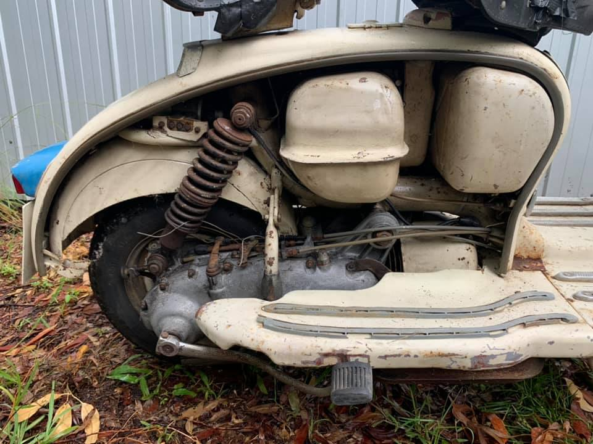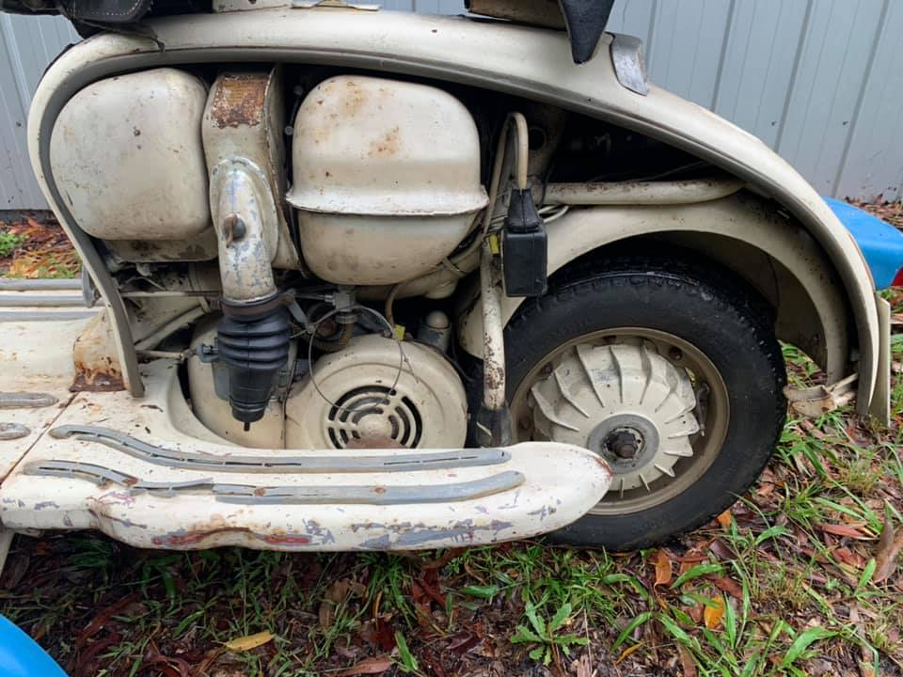
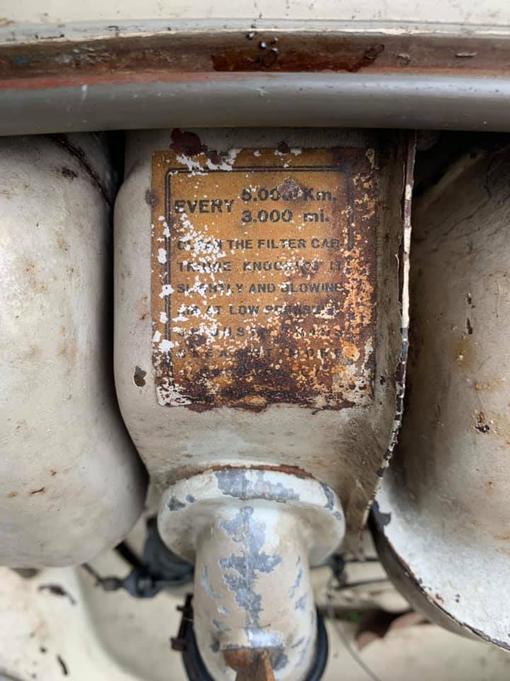
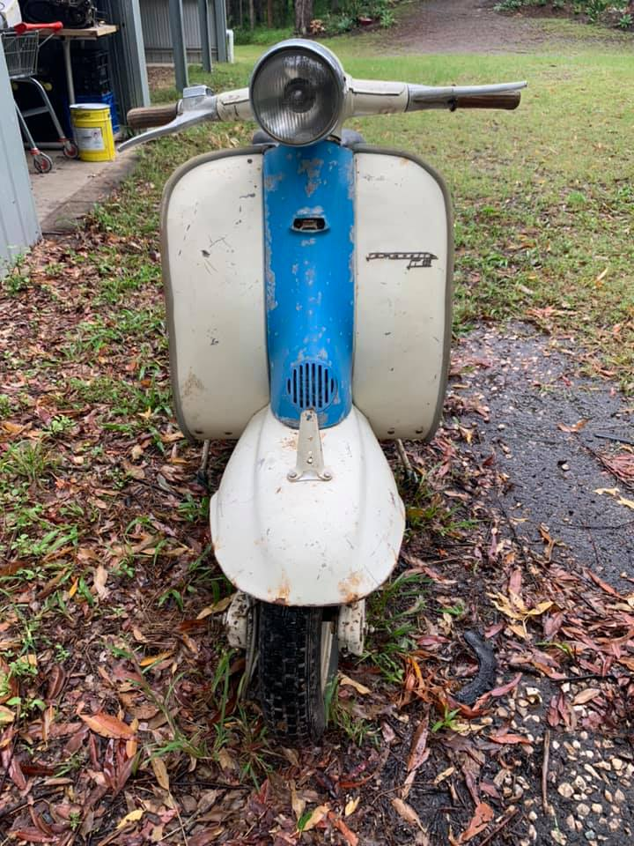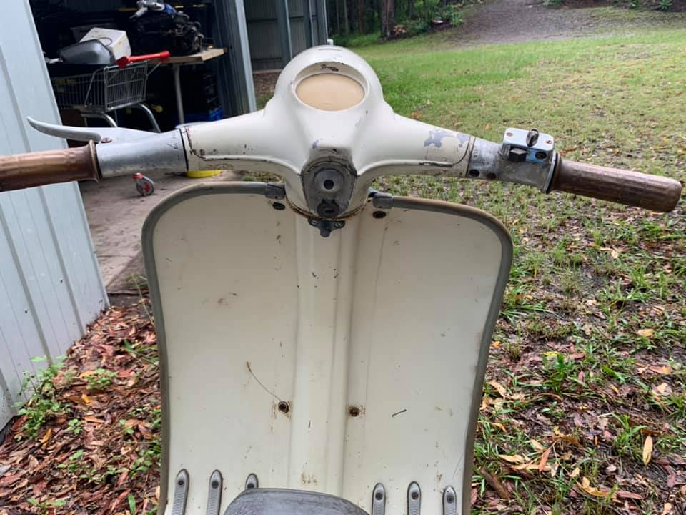
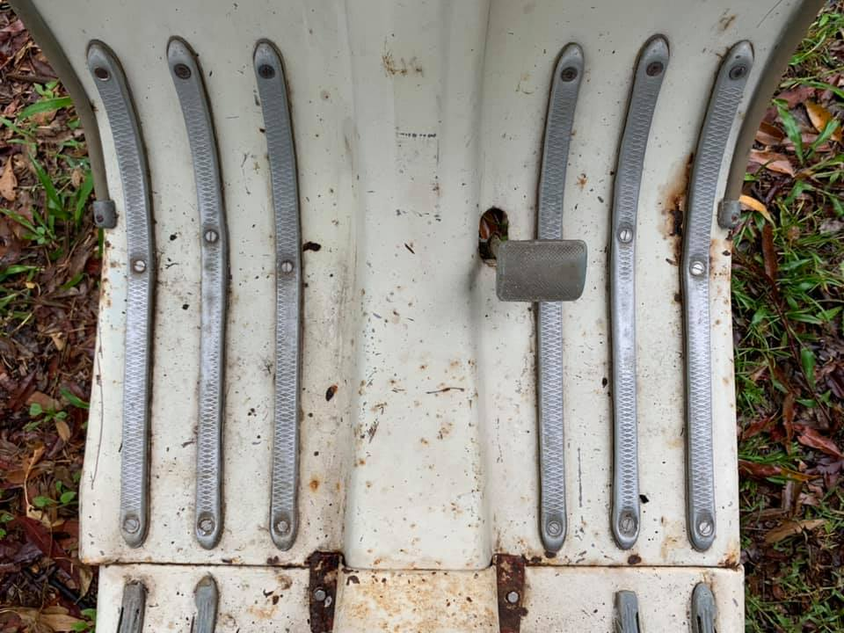
As the ad said, all the bits were there, just that the scooter needed a tear down and restoration. I have never owned or ridden a scooter before but have always been interested in them, especially the Lambretta.
The dismantling process started pretty much the day the scooter was dropped off to me by Danny. I took several photos of the wiring, to ensure that I had some sort of record of where the wires went.
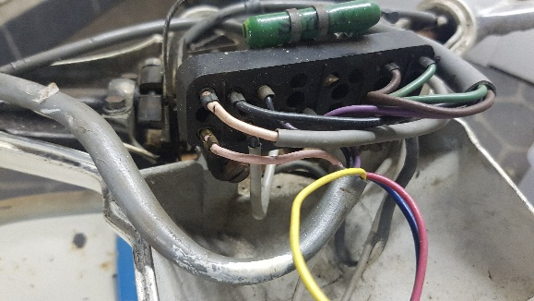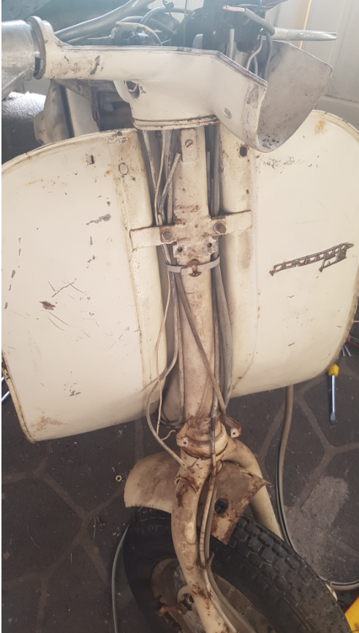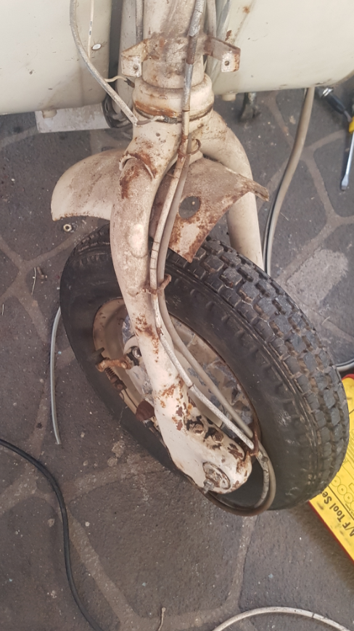
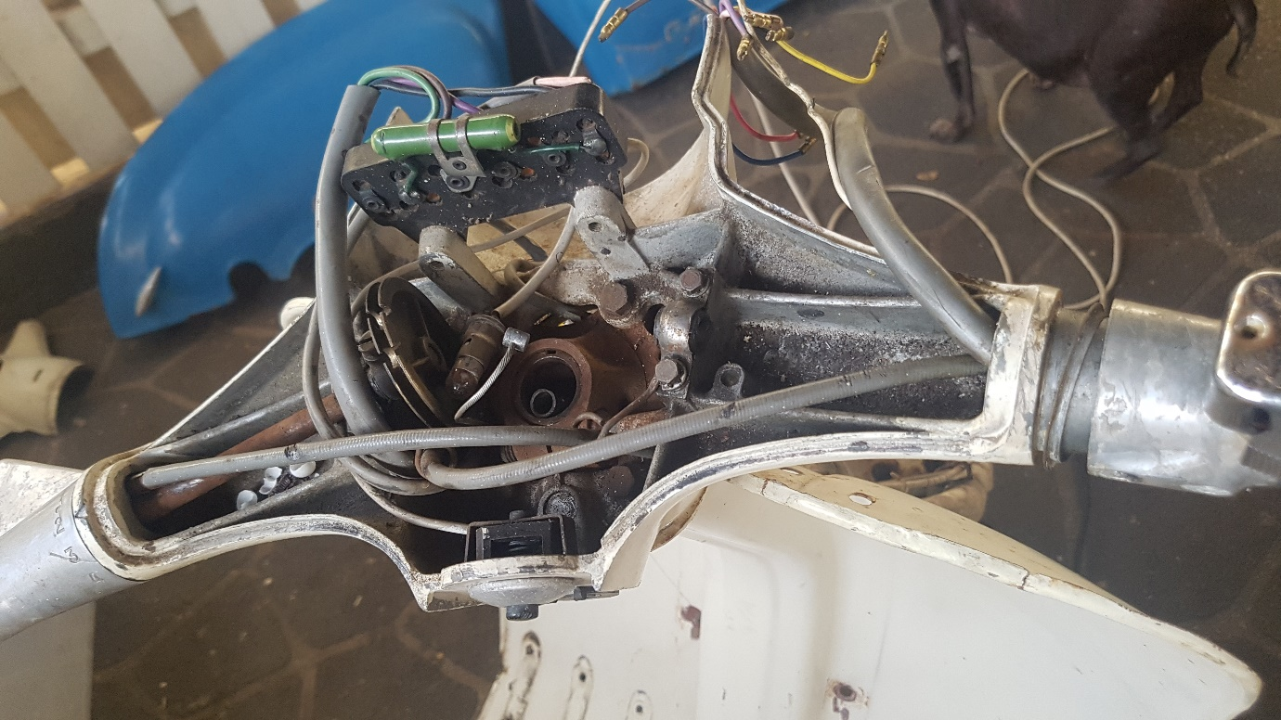
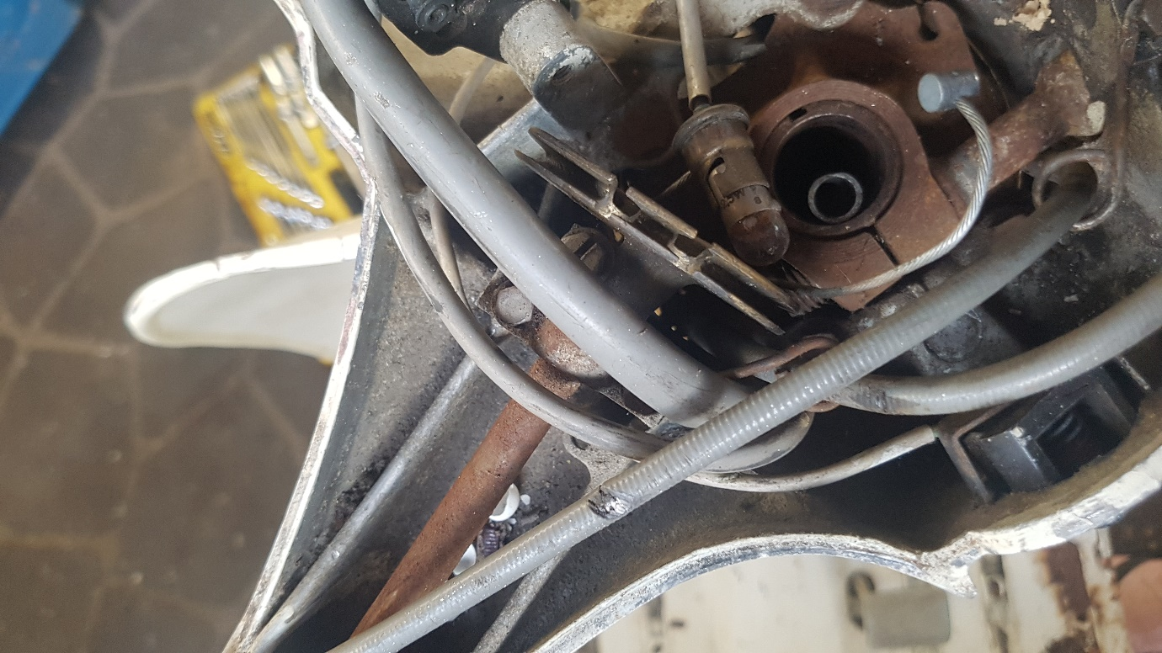
As can be seen I these pictures, everything is there, just a bit worse for wear. I disconnected and kept all the wiring, with the intention to reuse what I could. The clutch, gear, and accelerator cables I cut off and have replaced with new, as they were all old and damaged.

A few more pictures of the dismantled parts:
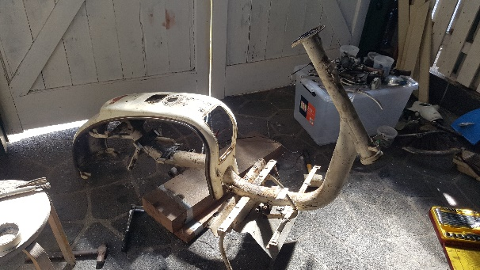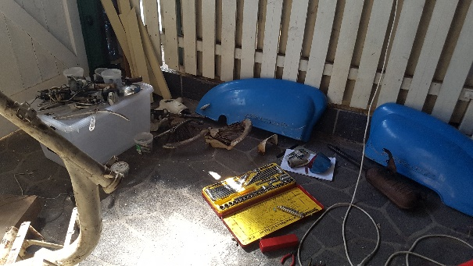
I was working on my Cagiva Mito at the same time:
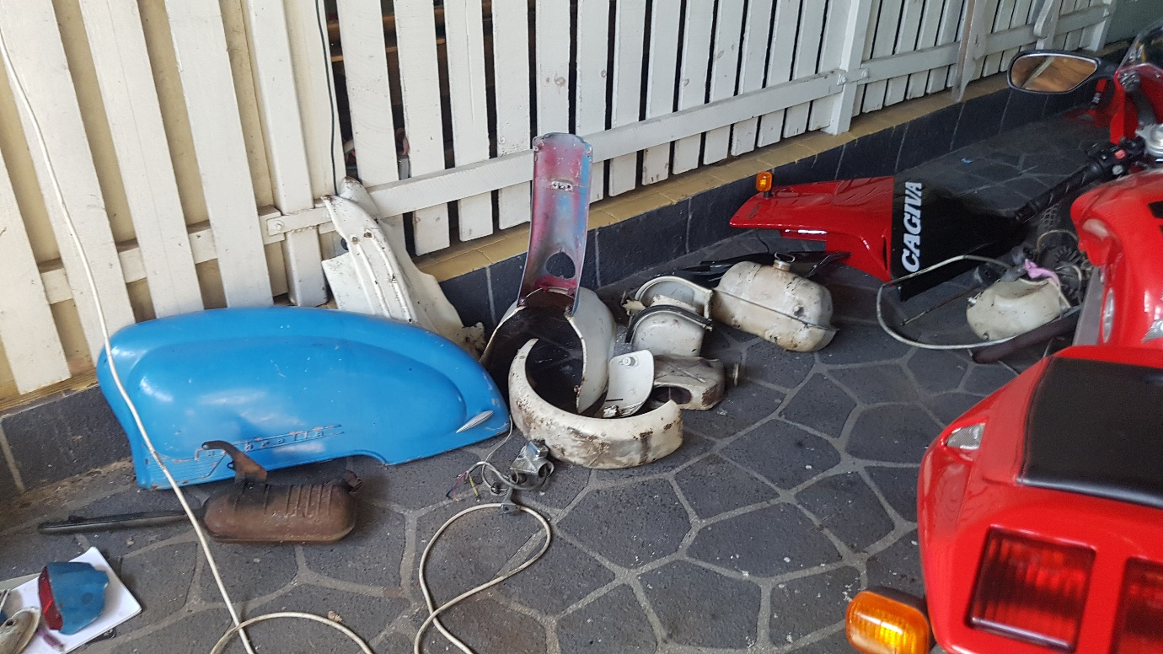
Then it was time to pull the engine apart and asses the insides. The piston did not move, it was stuck, as it hadn’t been run in some time.
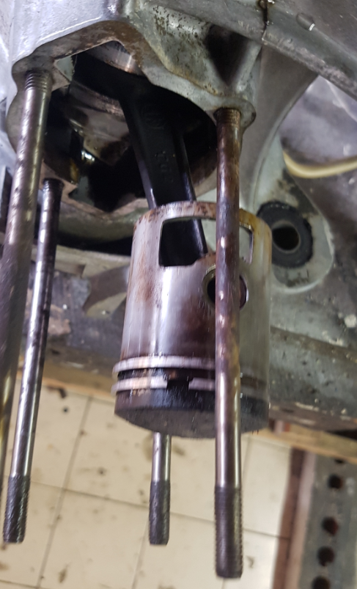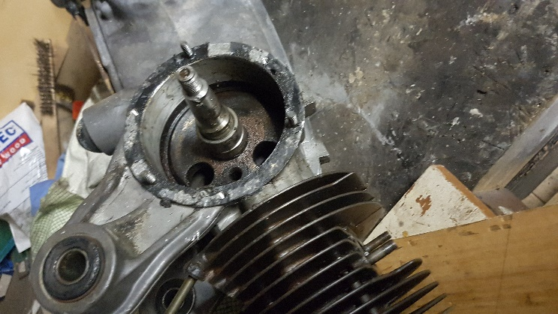
After a clean-up:
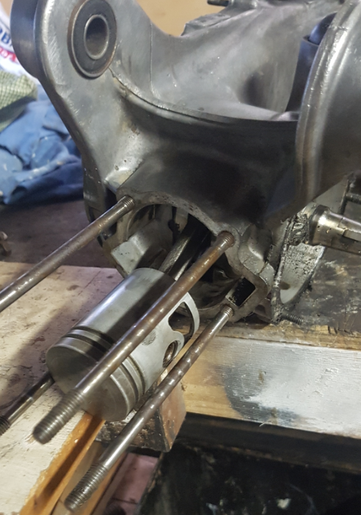
I replaced all bearings and seals; however, I left the big and little end as they were not worn. I had to source replacement rings from Nornda Automotive in Adelaide https://norndaautomotive.com.au/ as I struggled to get replacements from suppliers, perhaps because I did not know of Steve Diffey at the time.
The cast ring supplier needed a few key dimensions and within a few days I had them in hand, and they were to perfect specification.
The barrel and piston were still in spec, so I decided to keep them both and just hone the barrel. The top edge of the barrel had no wear lip at all, so it was not in bad condition after all. I also lapped the head and barrel mating surfaces.
By this stage I had joined the Lambretta club of Australia and had contacted Steve. I purchased a box load of replacement parts from him, including new clutch plates. The club had a meet at Ian’s place, which is not far from my home and I took the motor there to fit the new plates and chain tensioner. I have found the guys I’ve met in the club to be a barrel of laughs.

Reassembly Pictures and trying to machine out a broken stud. Unfortunately, I could not get it out as it seemed to be hardened steel or something like that.
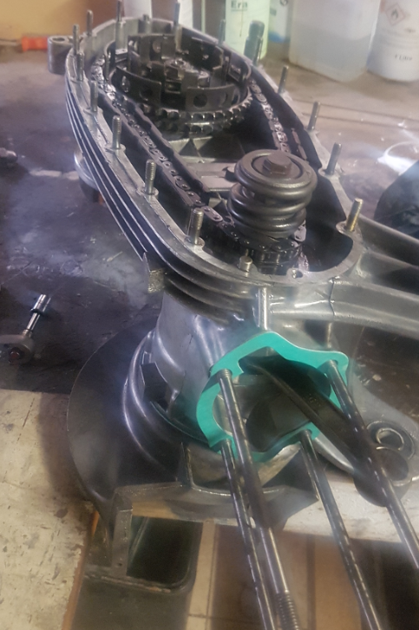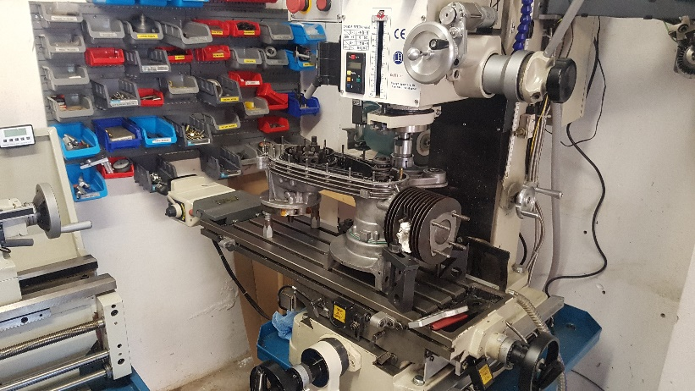
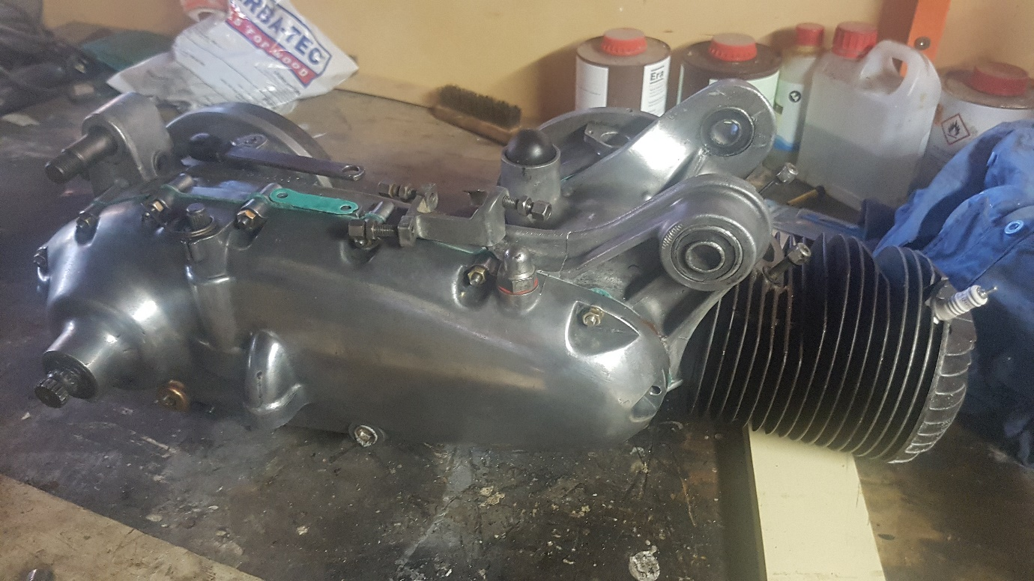
The scooter came with no keys and I noticed there are numbers on the steering lock and the glove box lock. I conducted an internet search and discovered Jem Booth in the UK. He cuts the original keys, so rather than throwing away the original locks, I decided to order a few keys from Jem. It took a few weeks to arrive to me. Jem was most helpful and his email address is – jmb548t@yahoo.co.uk
The steering lock on the scooter appeared to be missing a cover flap, so after searching images on the internet, I realised that it is supposed to have a flap. I decided I would turn one out of brass on the lathe and mill. Some pictures of that process:
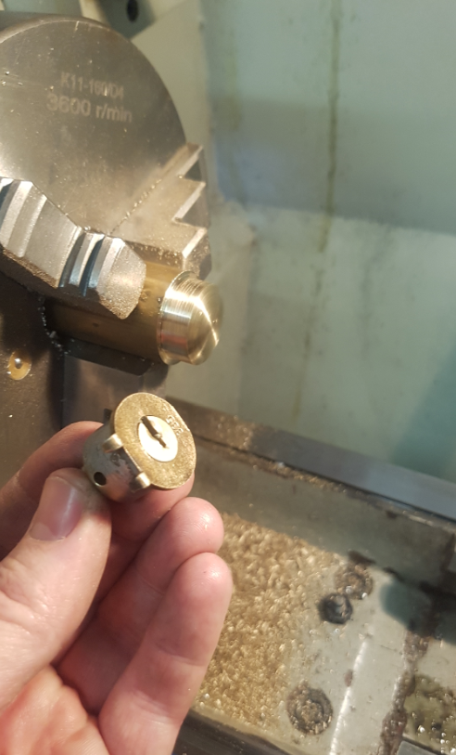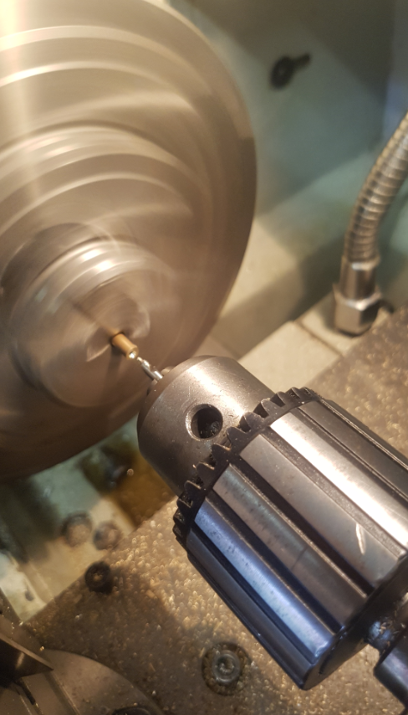
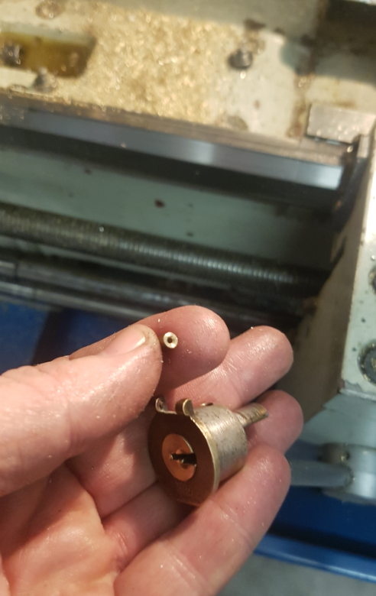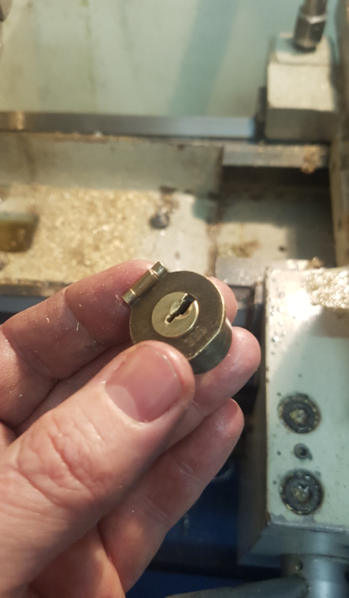
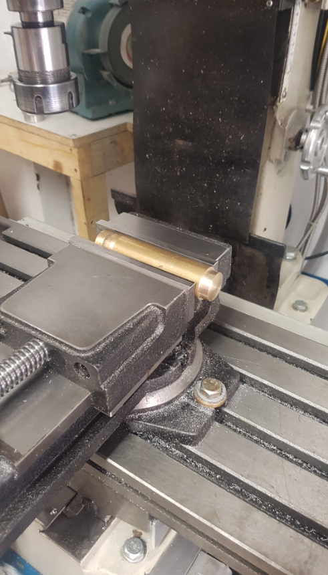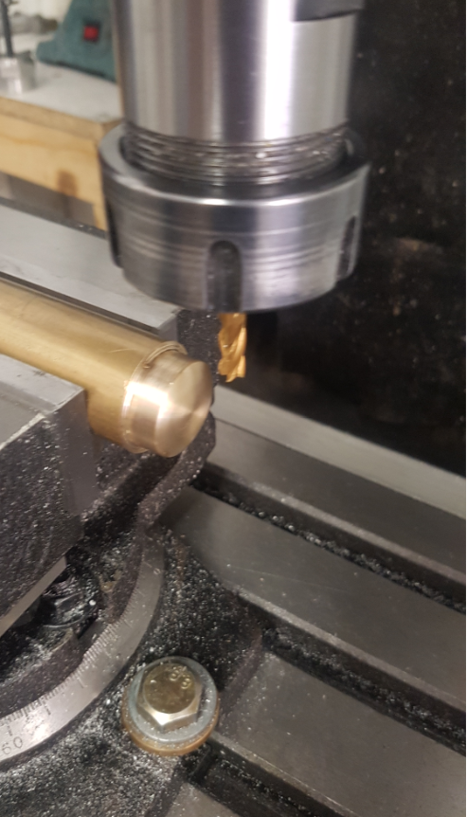
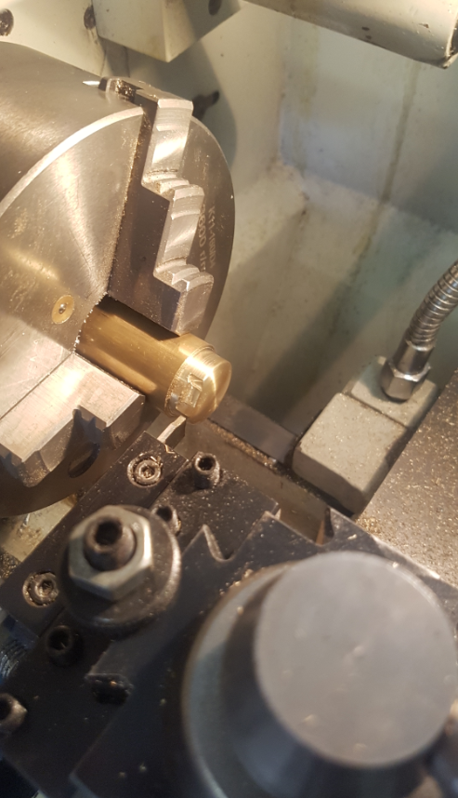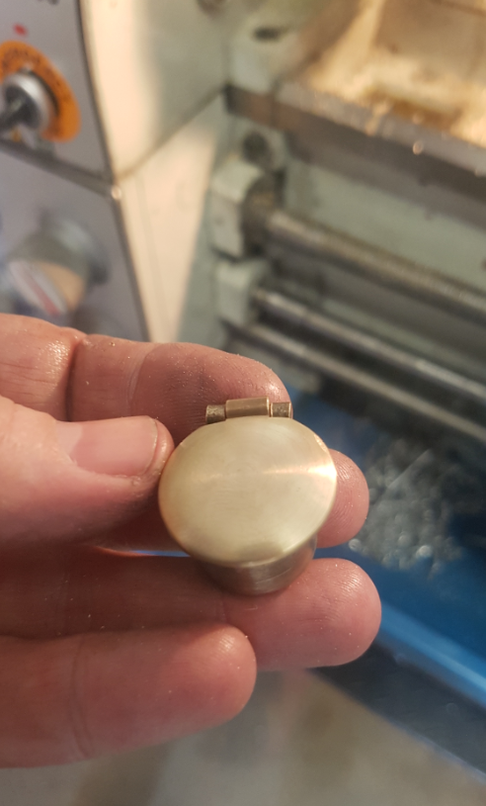
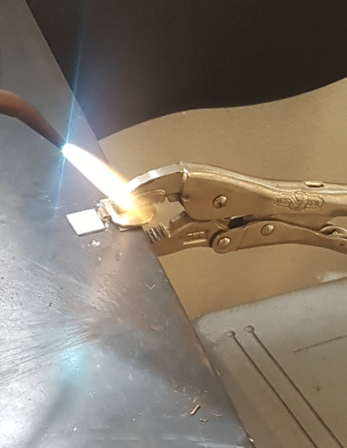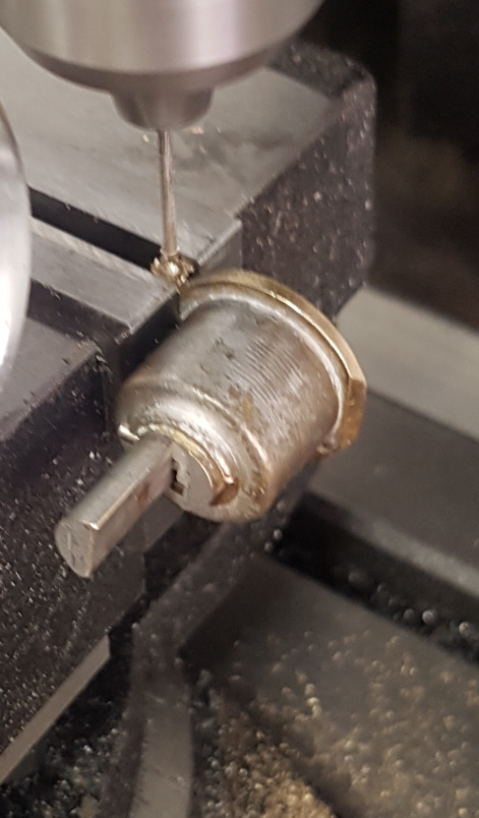
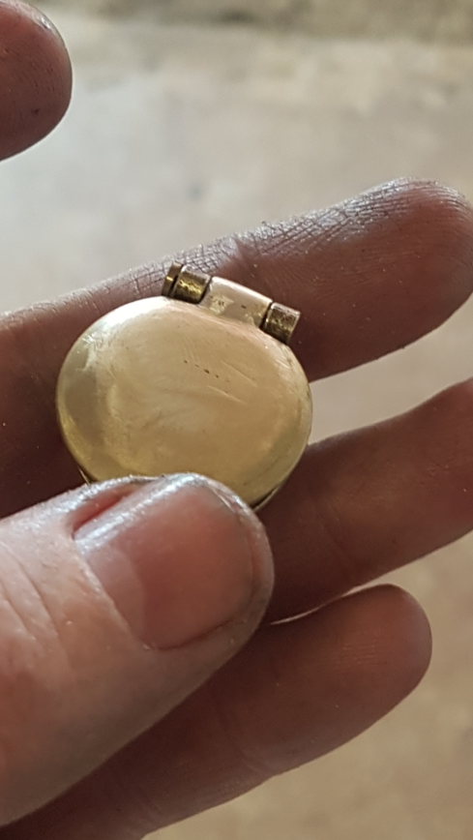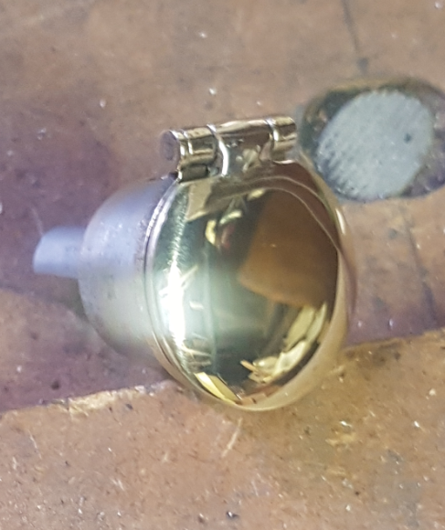

The rear brake housing has two broken fins. I took it to a friend who can tig weld. I brought some aluminium with me which I shaped to match the interface which would be welded. It was a nightmare for him to weld, the arc was diving all over the place as the parent material isn’t the best, however it may have been more due to the steel brake sleeve inside which was causing havoc with the process. Regardless, he was able to get enough weld on there for me to be able to file back to shape.
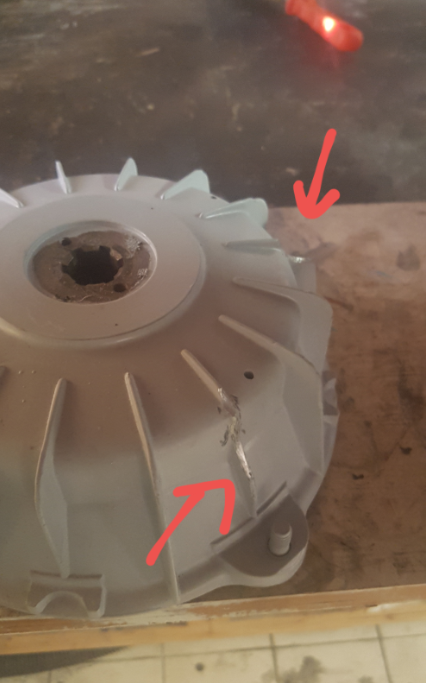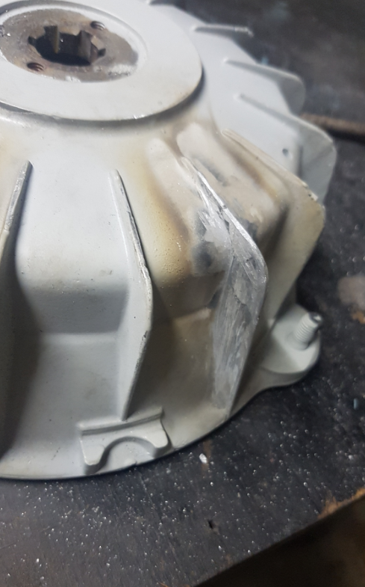
I took all of the panels and parts to Refurb Restoration to have all of the rust and paint removed. Brad did a great job. I believe he acid dipped the steel and blasted the aluminum parts, then applied a 2 pack primer. http://refurbrestoration.com/
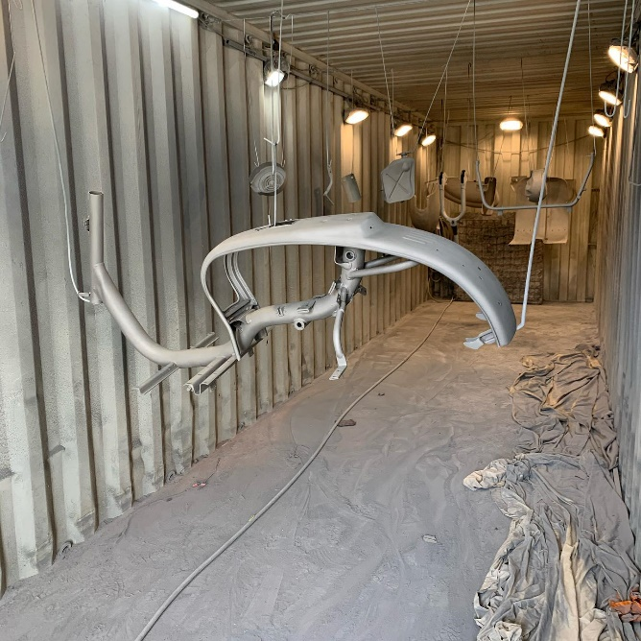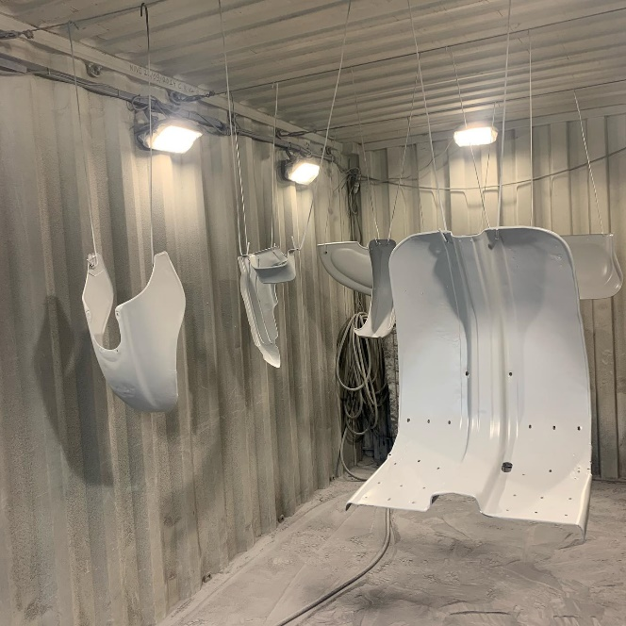

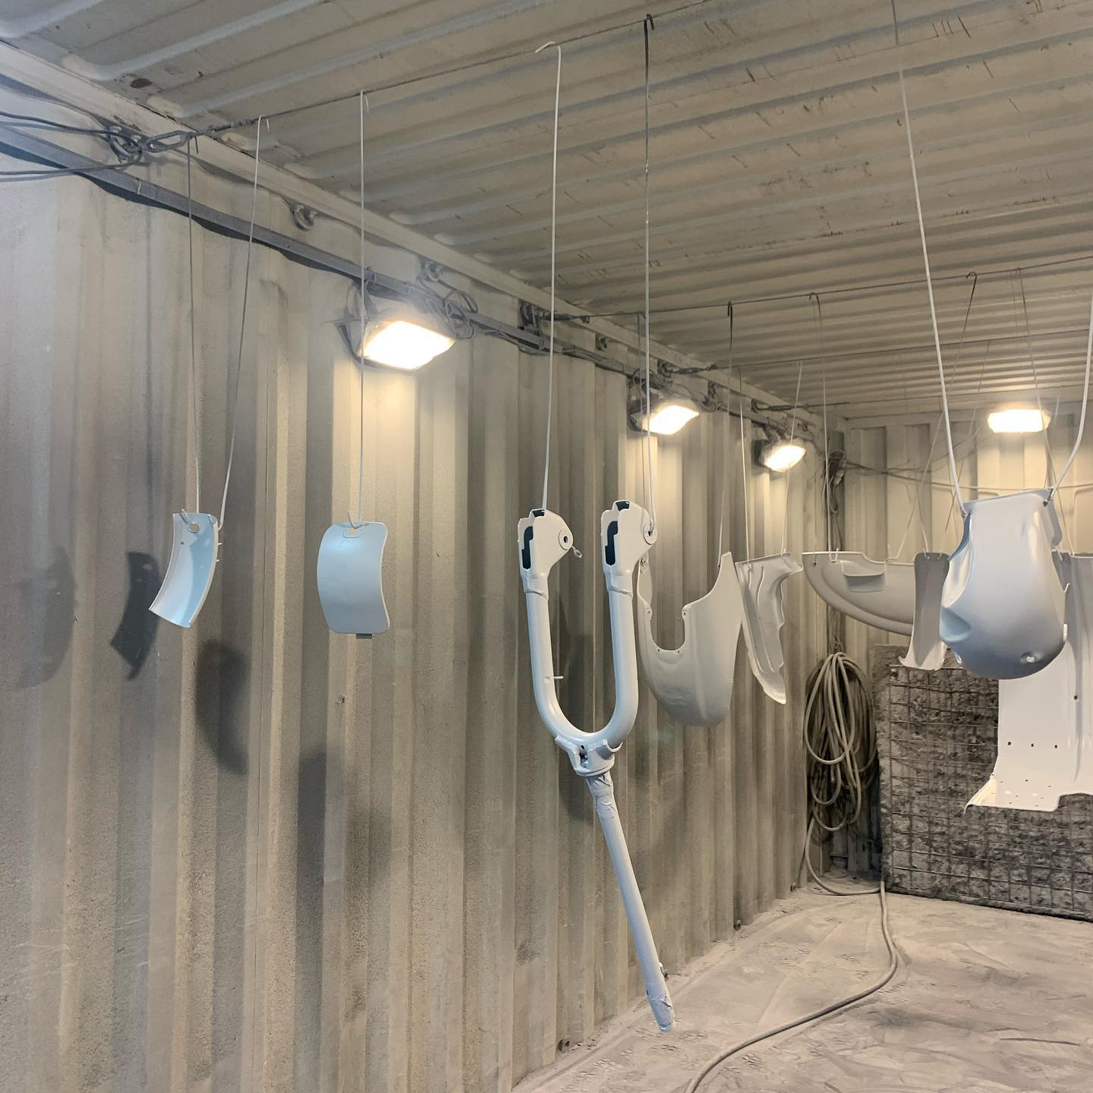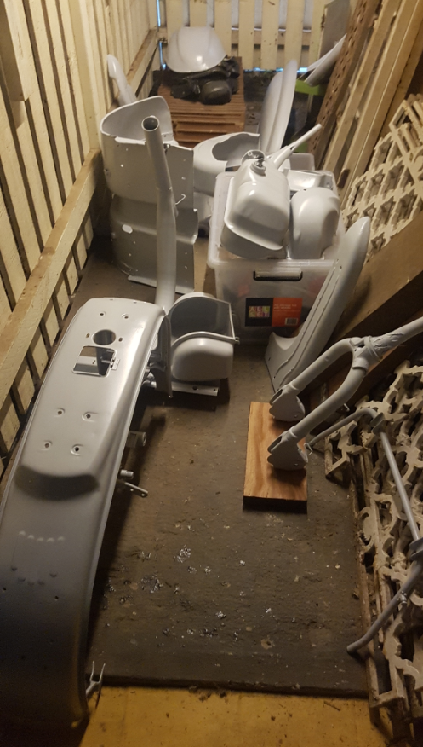

I then spen months of weekends straightening panels. The front guard and the leg shield were the worts panels, however I was determined to keep them rather than replace them for new. Im told that the new panels don’t fit that well any way and it takes a lot of work to get them right.
I had to cut some metal out of the leg shield and weld new metal in. I also welded a round steel bar (coathanger wire) in behind the lip of the front guard and down the sides of the leg shield lips to help with stiffening.
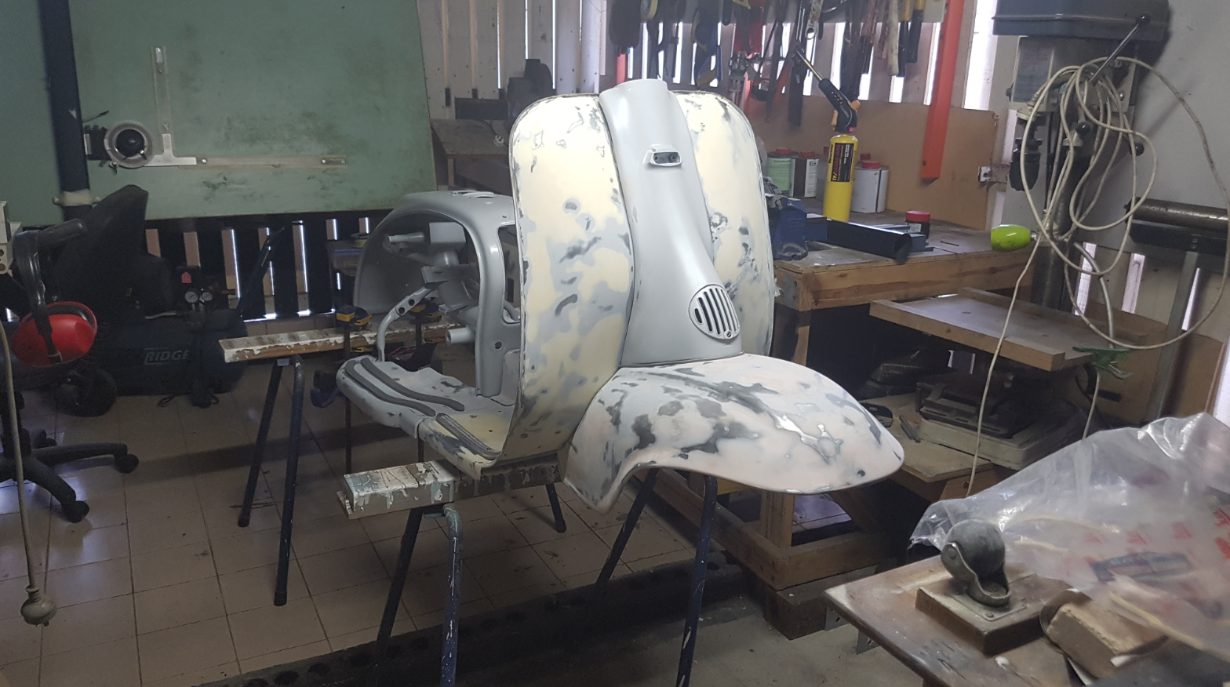
I made sure to conduct a dry fit up of all of the panels to make sure they would sit true. I also cut the rubbers and test fit, so that after paint I knew it would go together.
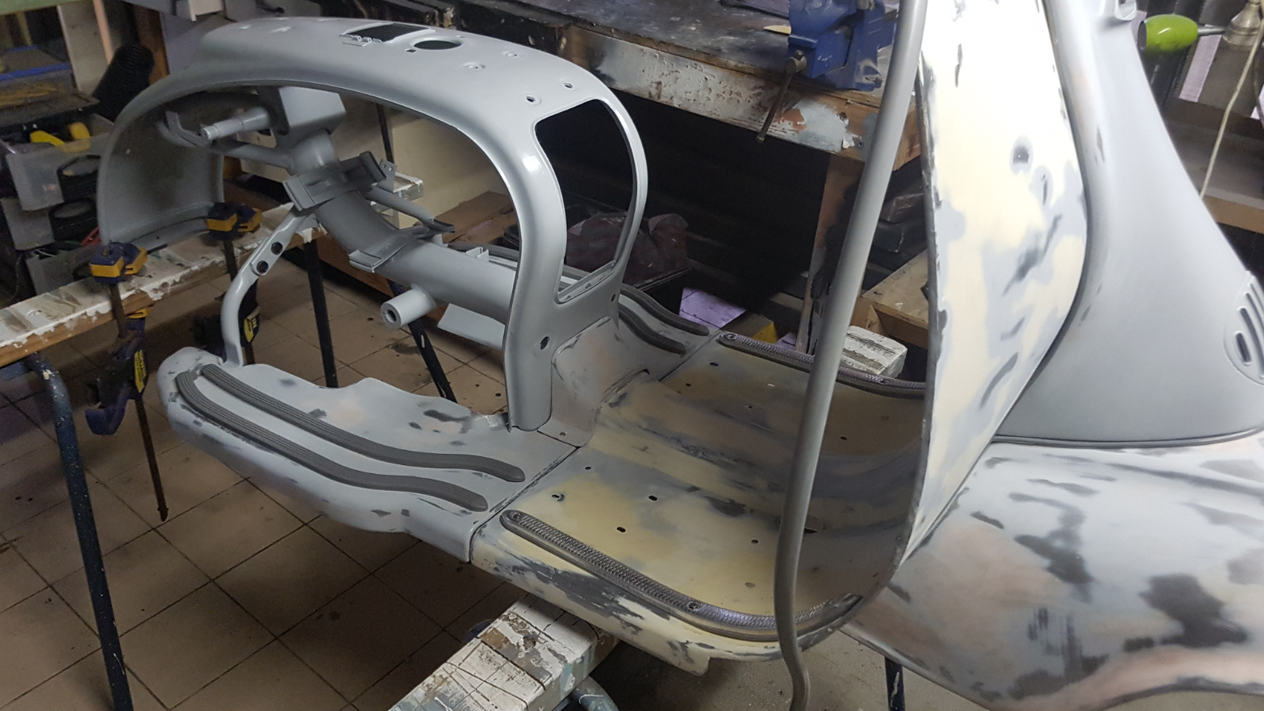

I then spray putty primed in 2 pack all of the parts and spent weeks rubbing them back in preparation for painting. I also decided to keep the original rims and colour match them to the body.
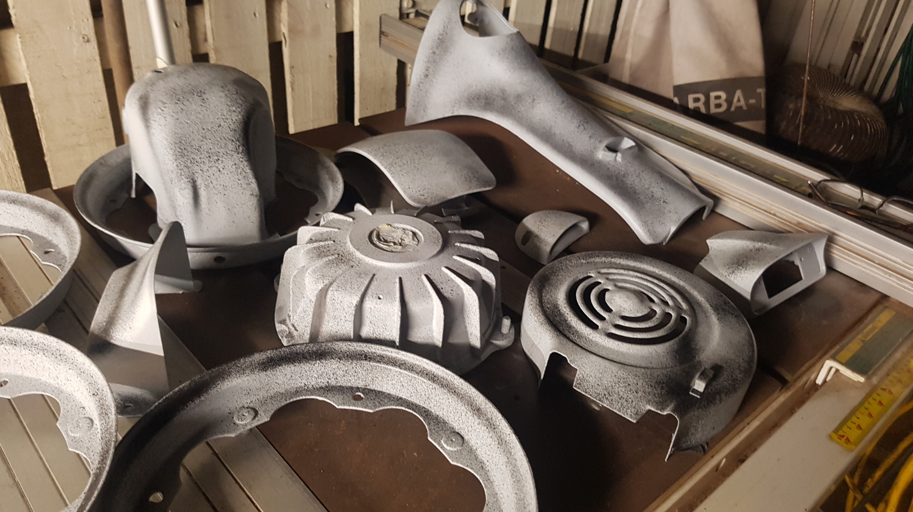

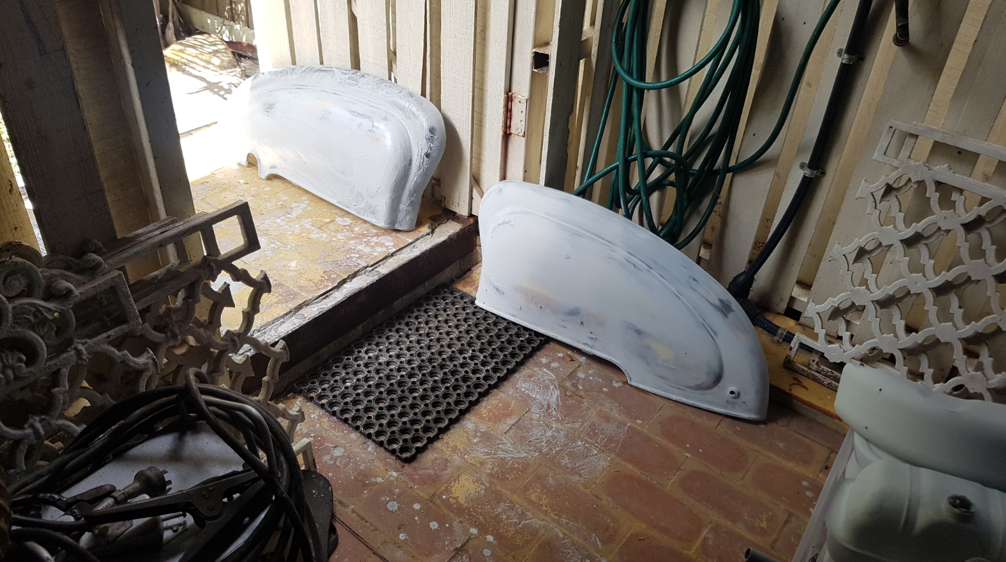
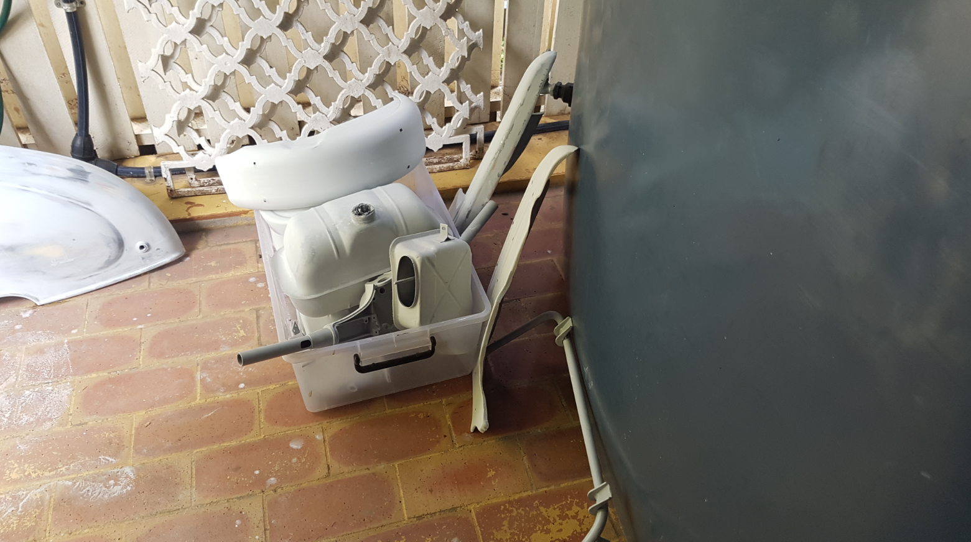
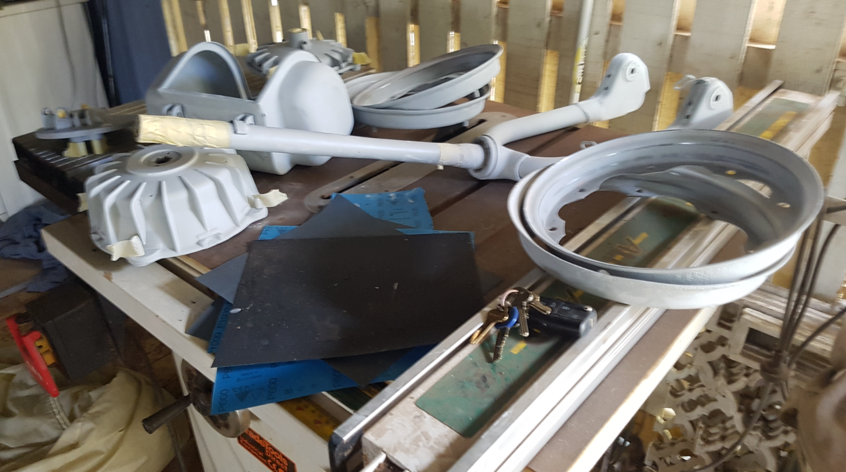
I hired a booth for a few days out at Oxley, west of Brisbane, to paint the scooter. I had the paint colour matched to the original colour pallets which I got off of Ian Brill from the Lambretta club of Australia. Ian also helped me a number of times with some specialised tools, like the fly wheel puller and engine stand.
I have painted cars when I was younger, so I figured I could manage to paint a scooter. The sheer number of parts which require paint is daunting!
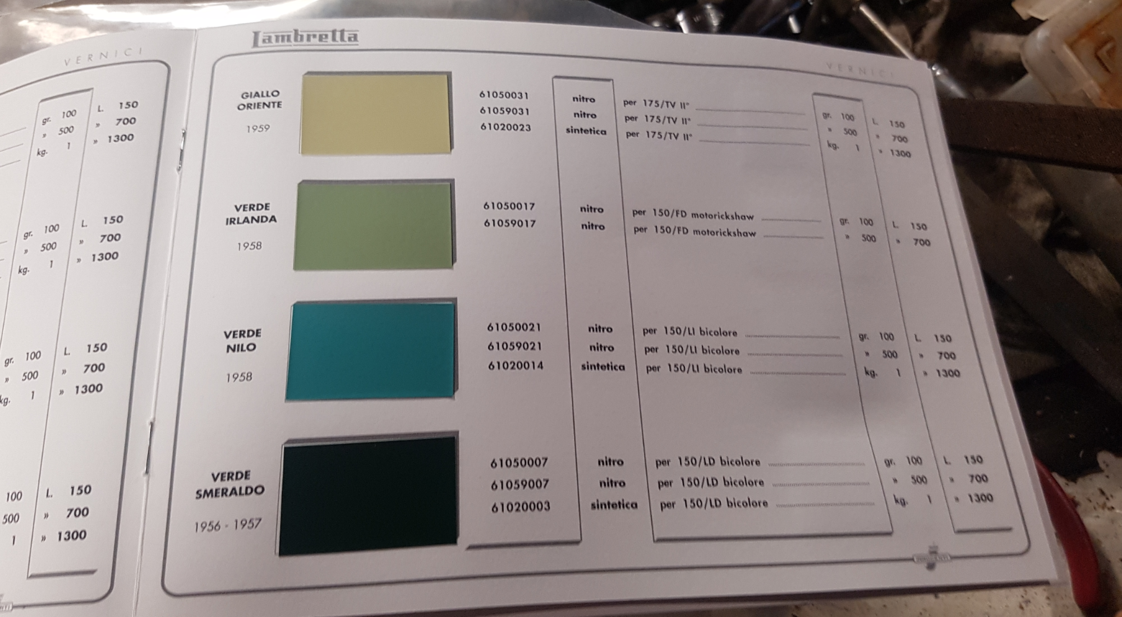
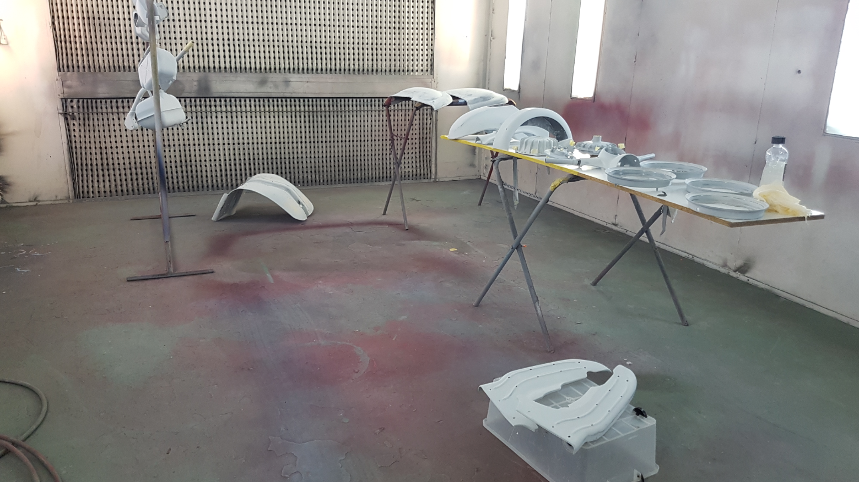
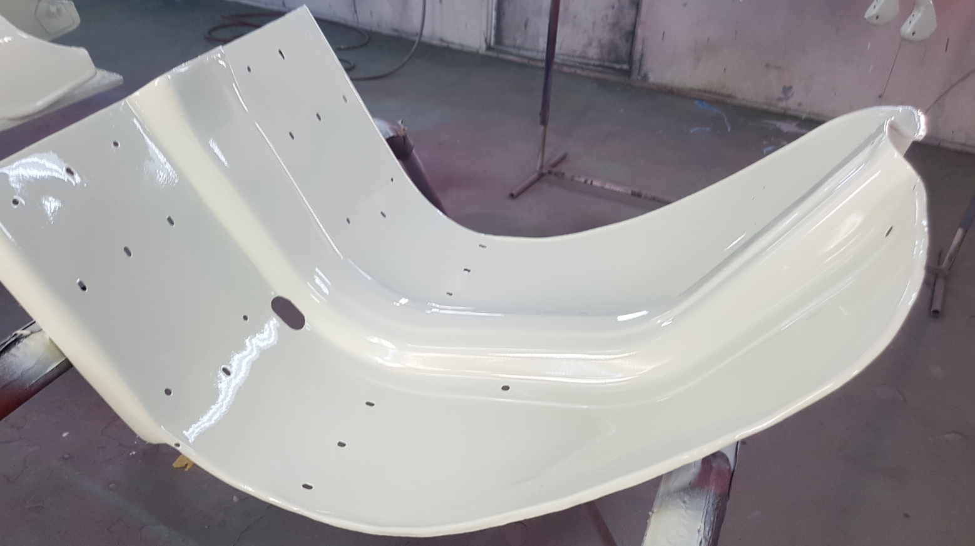
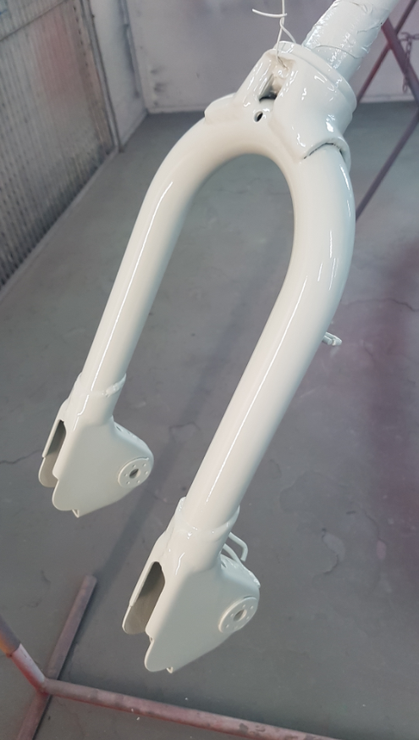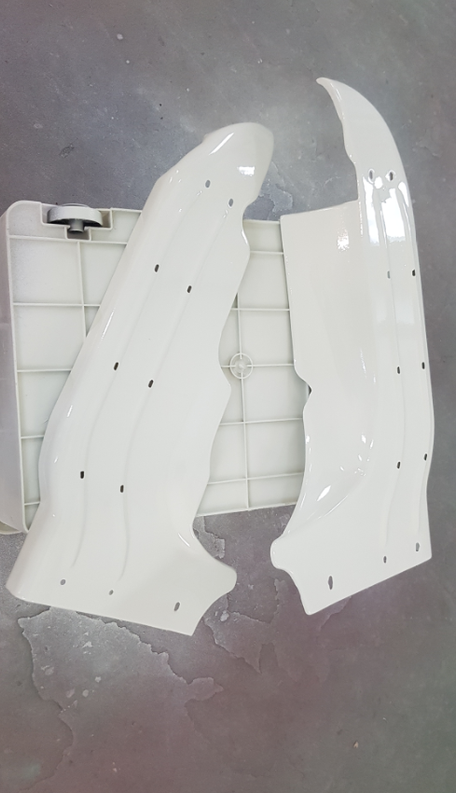

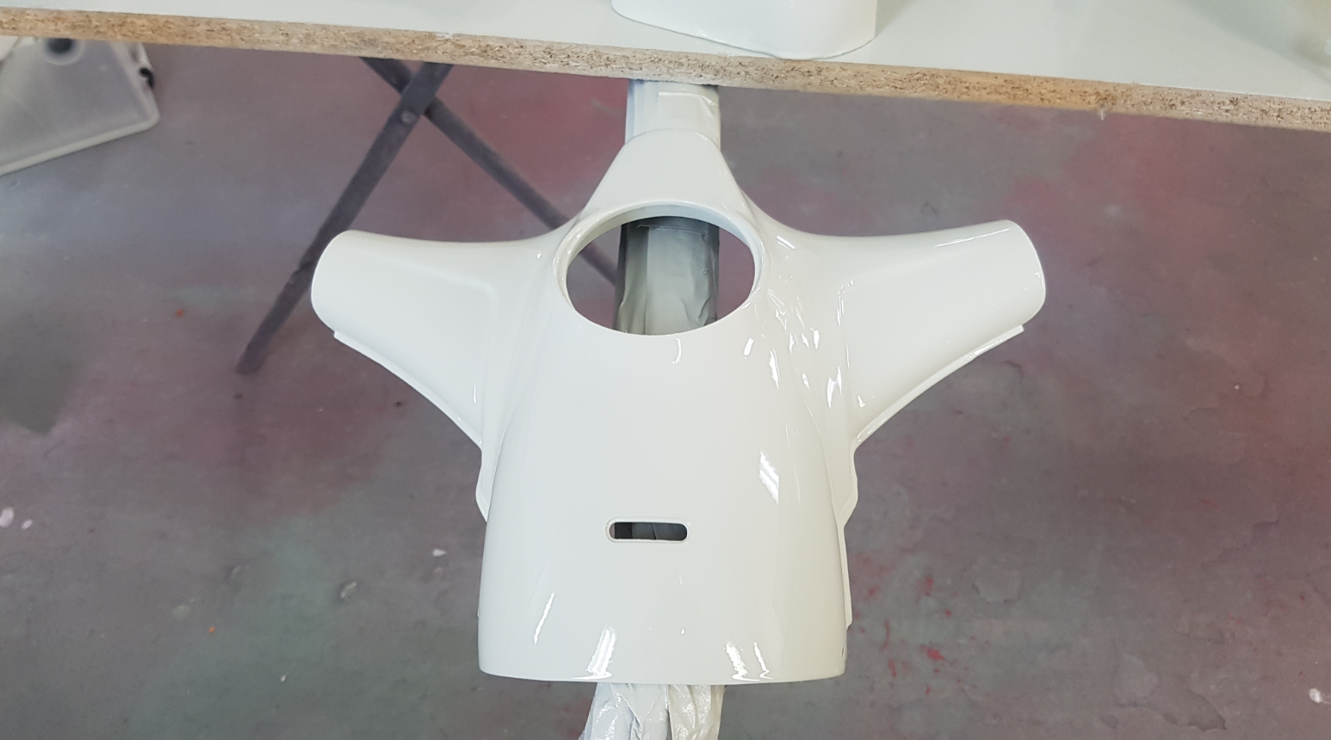
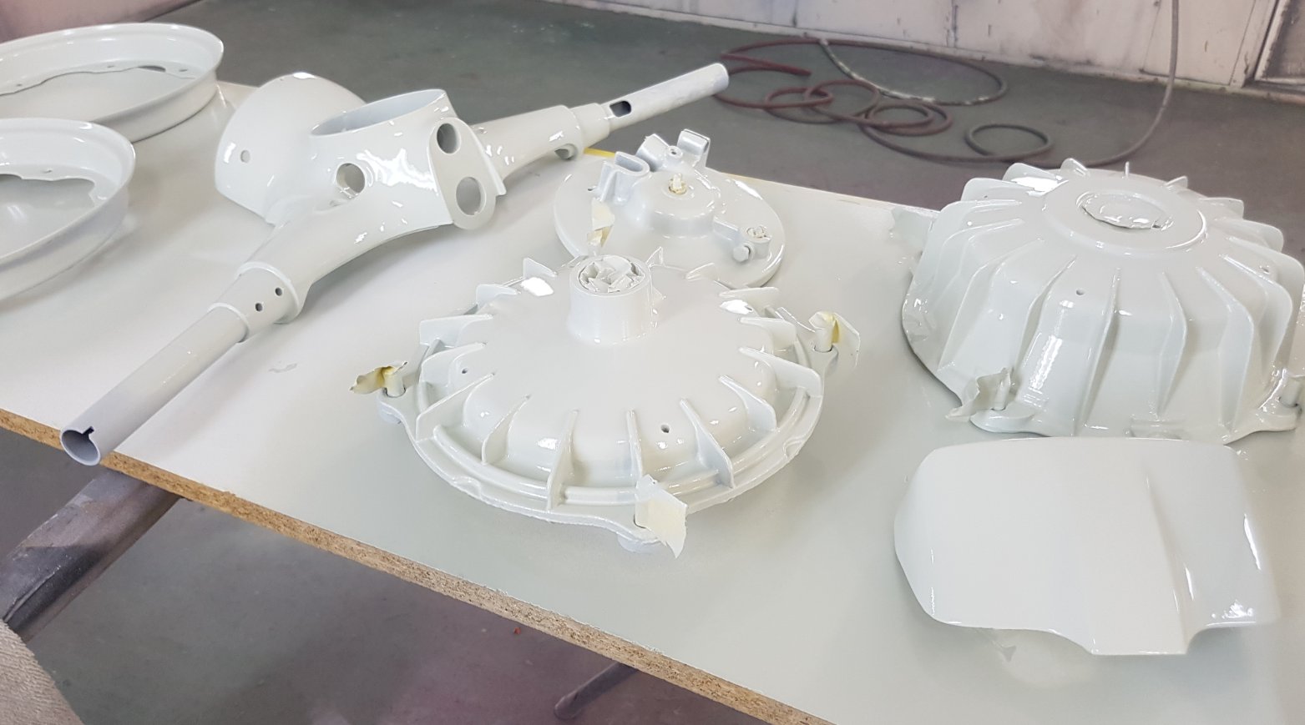
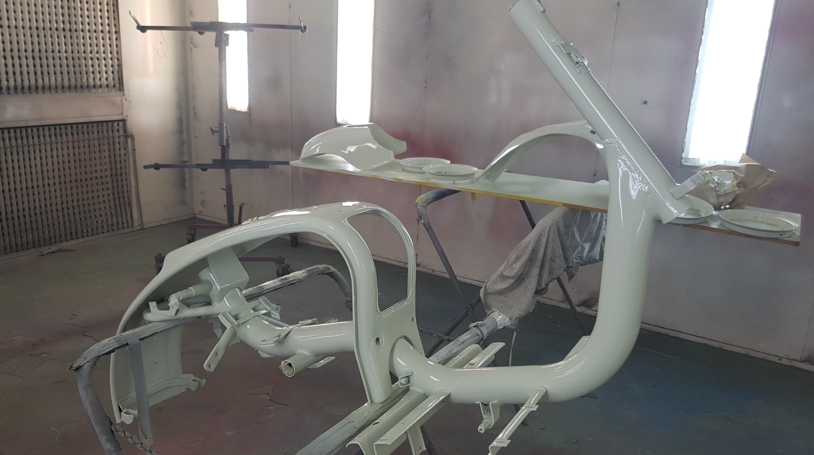
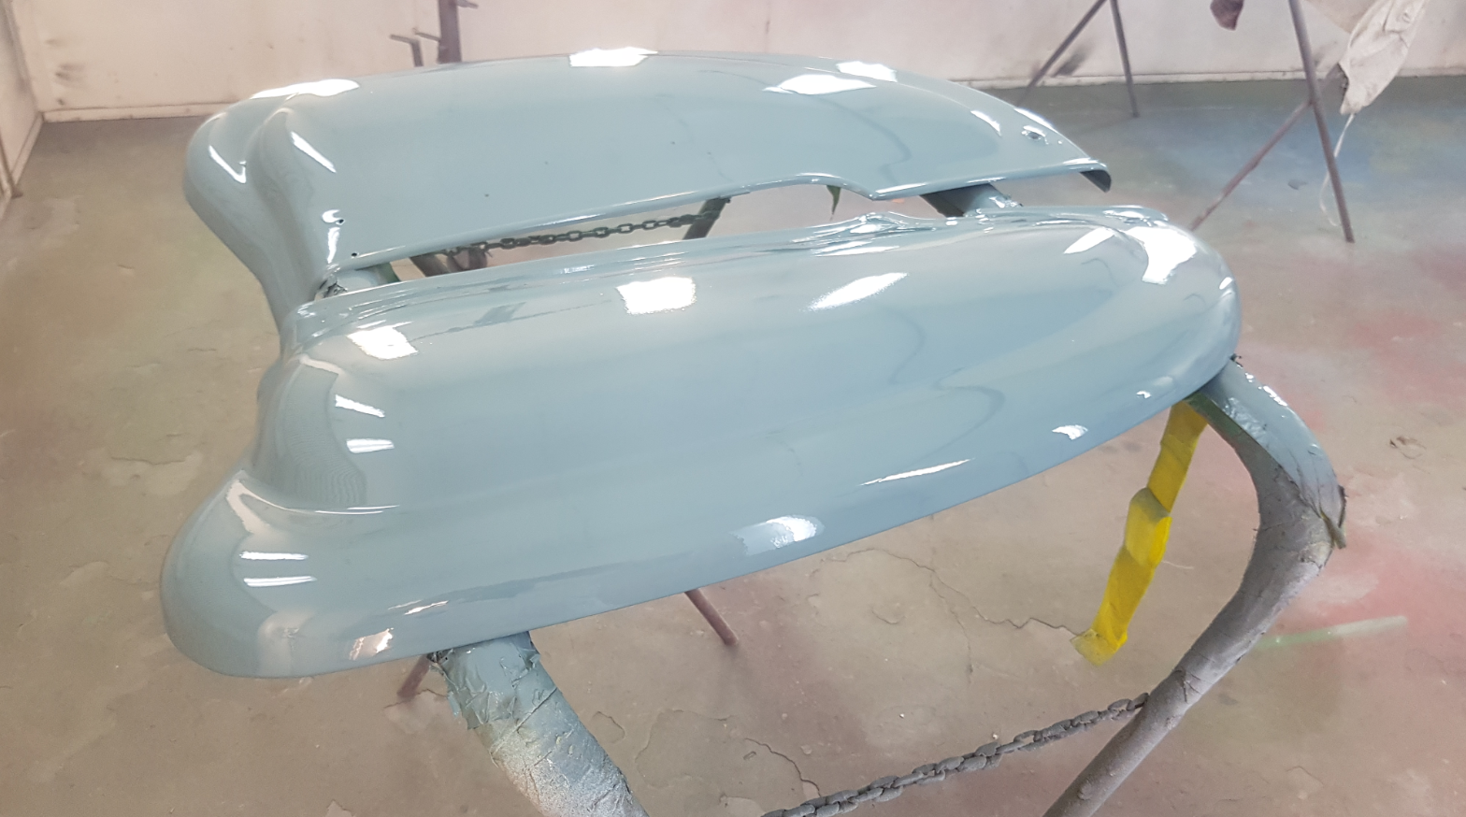
I finished painting and a fly landed on the side panel! I managed to walk about 100mm on the panel before stopping and getting stuck to the panel. I managed to pick it off without touching the panel.
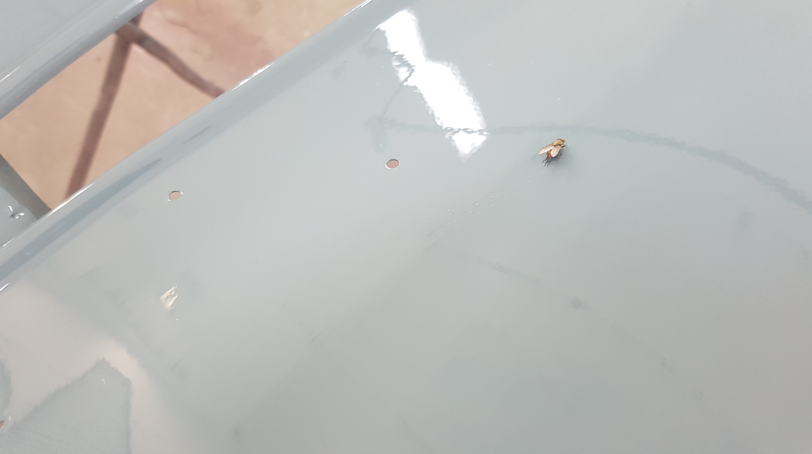

I ended up getting in contact with Steve Diffey, in NSW from Lambretta Obcessions. He has been extremely helpful and has been able to supply me with just about every part I have required for this restoration. He wastes no time in shipping goods, generally I have them in hand the following day from when he sends them! steve@lambrettaobsessions.com
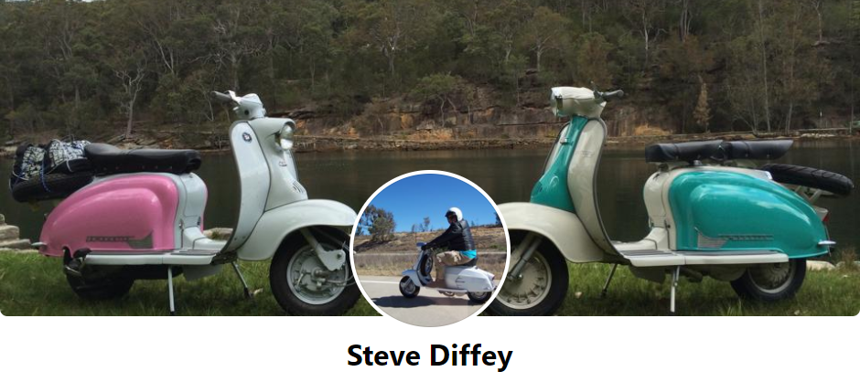
I have ordered many new parts, and have tried as best as I can to keep and restore as many original parts as possible. The sticky’s manual has been a big help also.
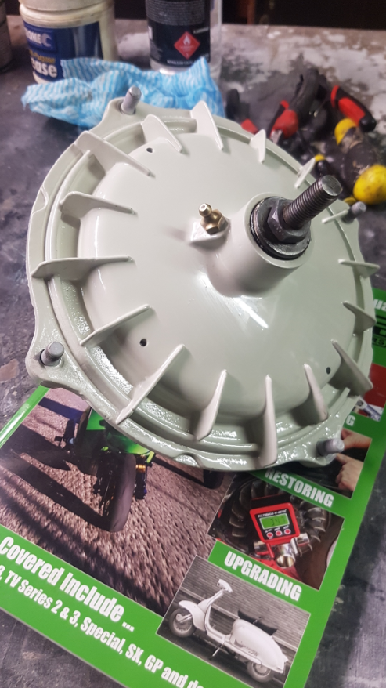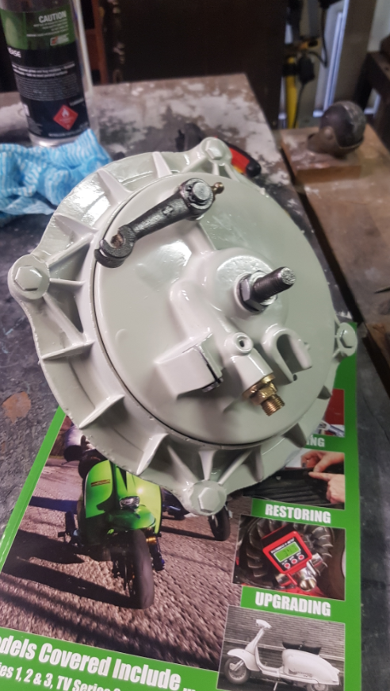
Steve advised me in one of the many photos I sent him that the cable guide on the front fork was pointing the wrong direction and sure enough, after looking further into it, it most certainly was! I decided to make a new one from a steel nail and replace it.
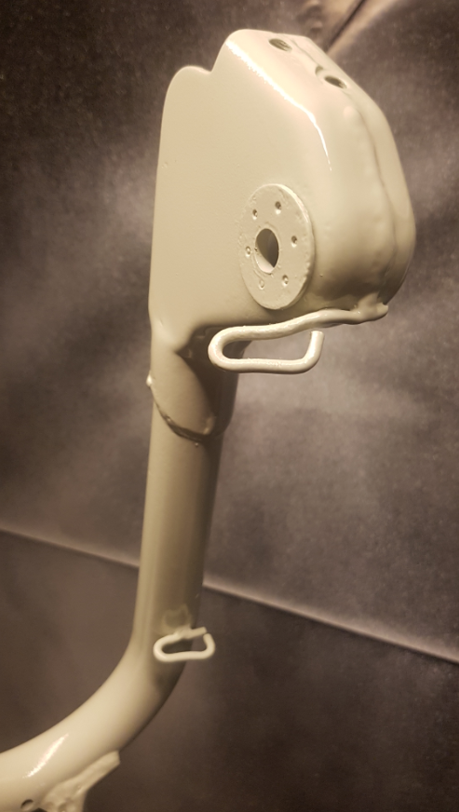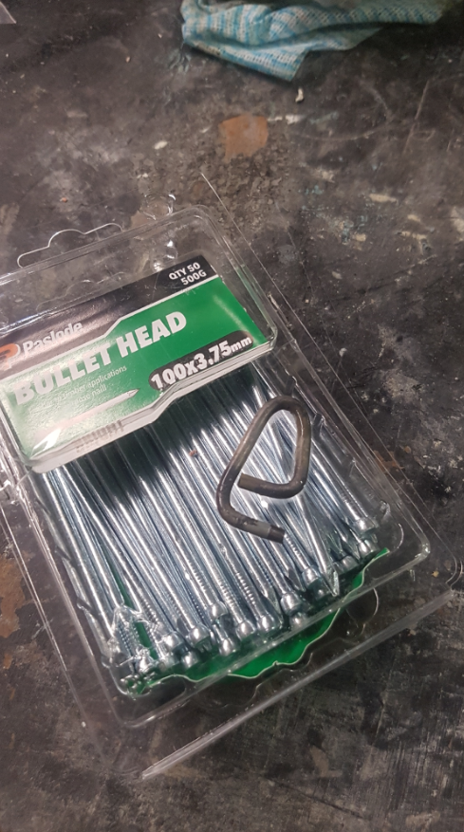
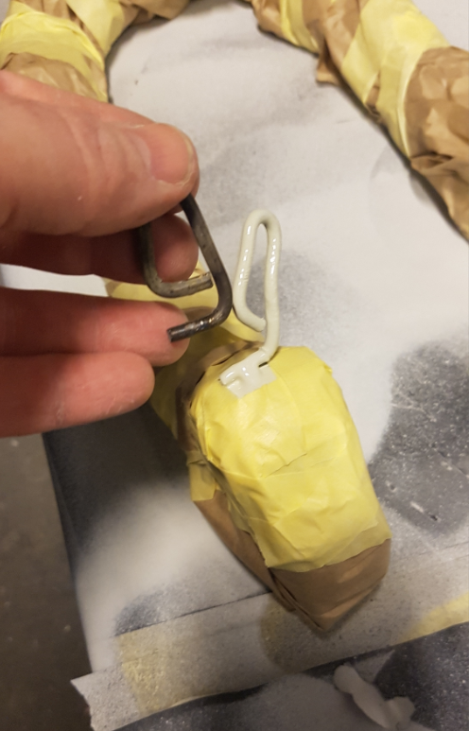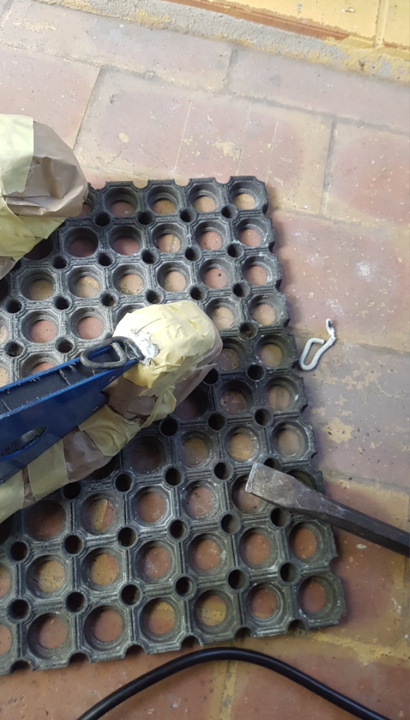

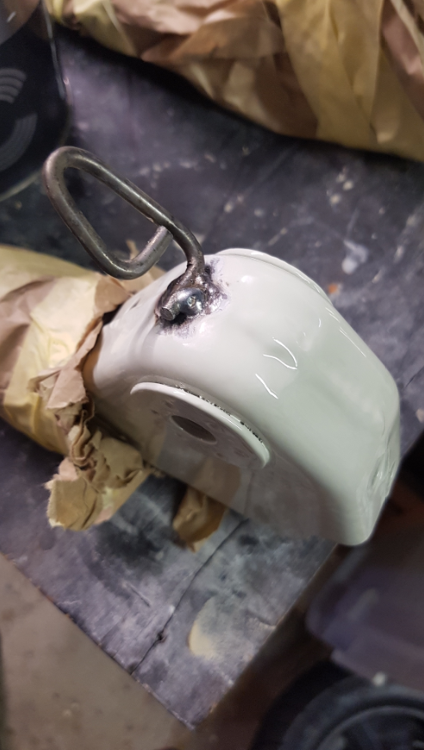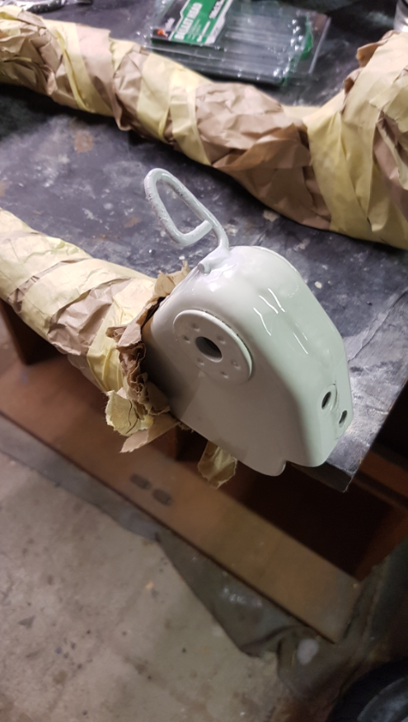
Reassembly of the scooter is time consuming. This picture shows the colours of I painted it better than those in the booth. I believe there was too much white light in the booth, which has washed out the colour on the previou photos.
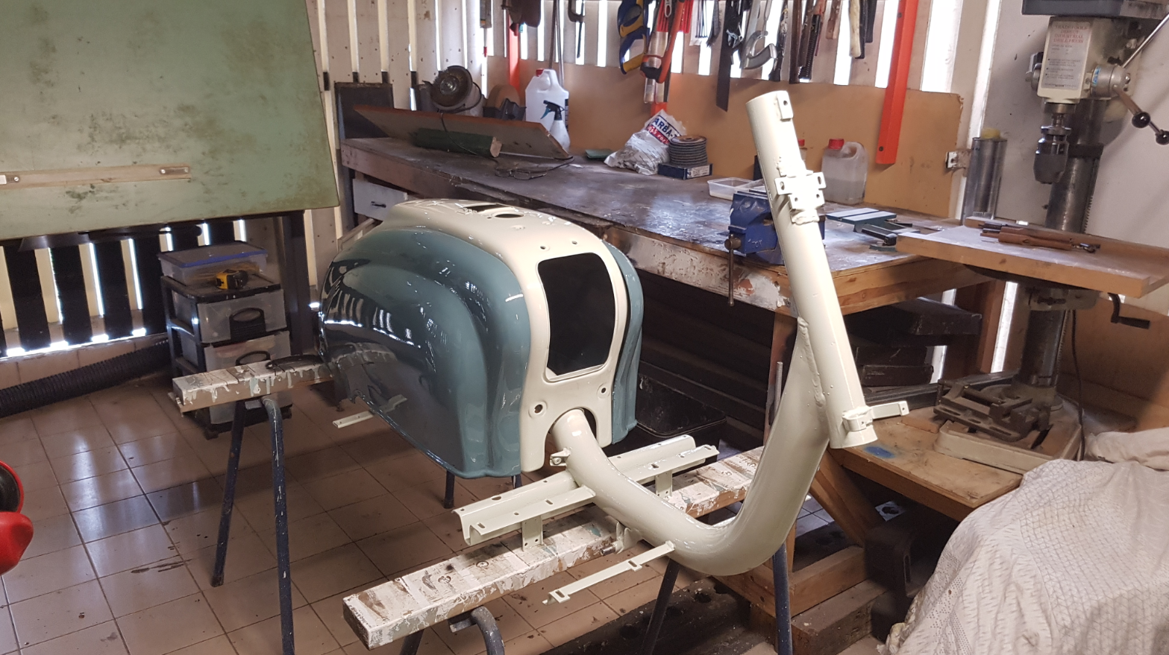
Im quite happy with the paint finish. The finish off the gun has turned out better than expected.
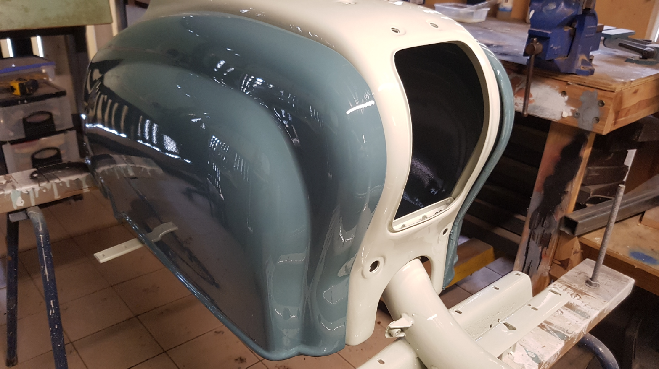

The assembly:
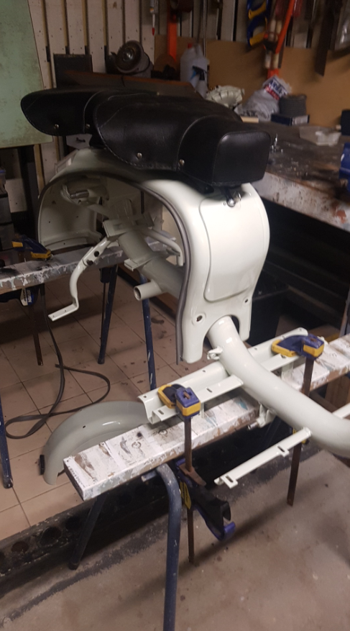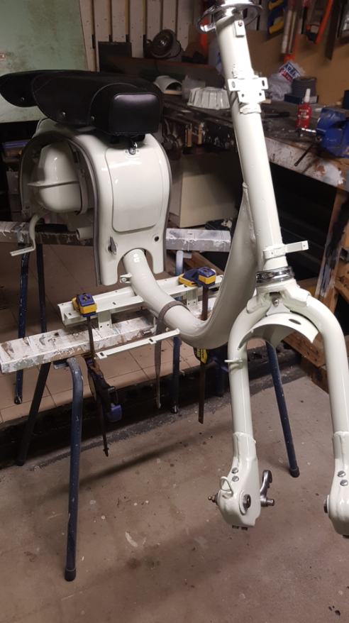
Steve suggested that I strip down the middle, the felt which sits between the tank and tank strap, to make it easier to install. With all advice he has given me, this was another piece of advice I greatly appreciated.
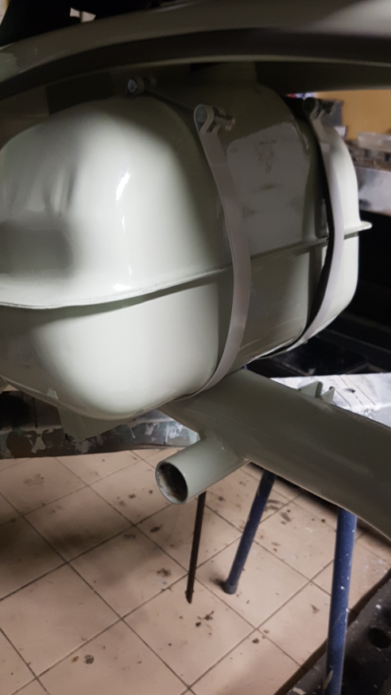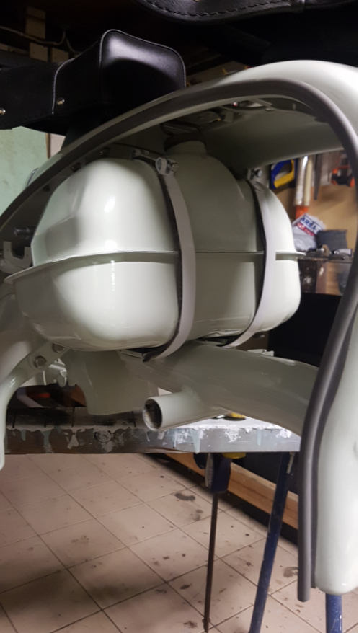
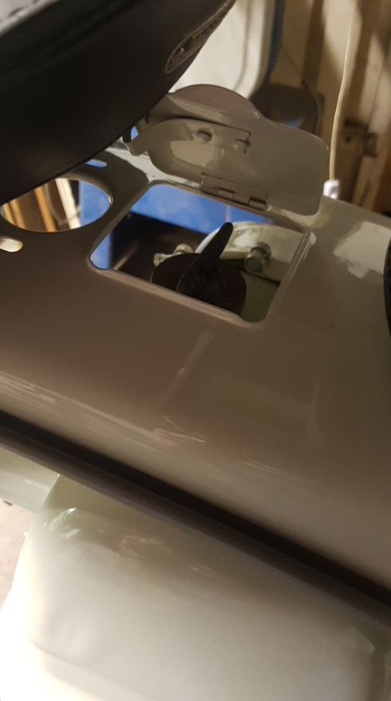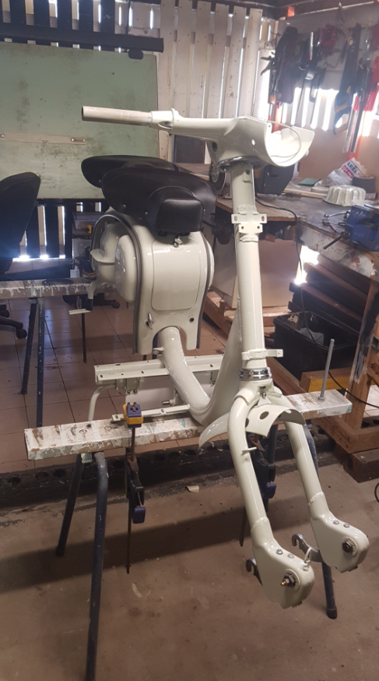

Running all of the new wires and cables took many hours to get right.
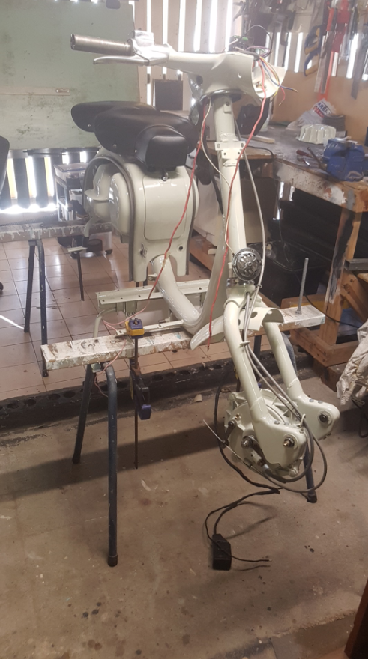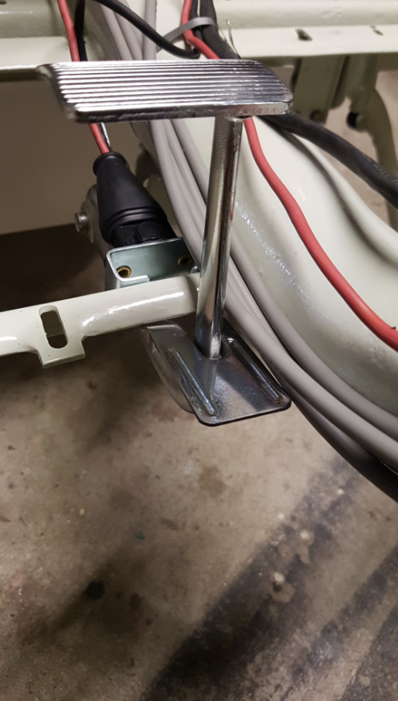
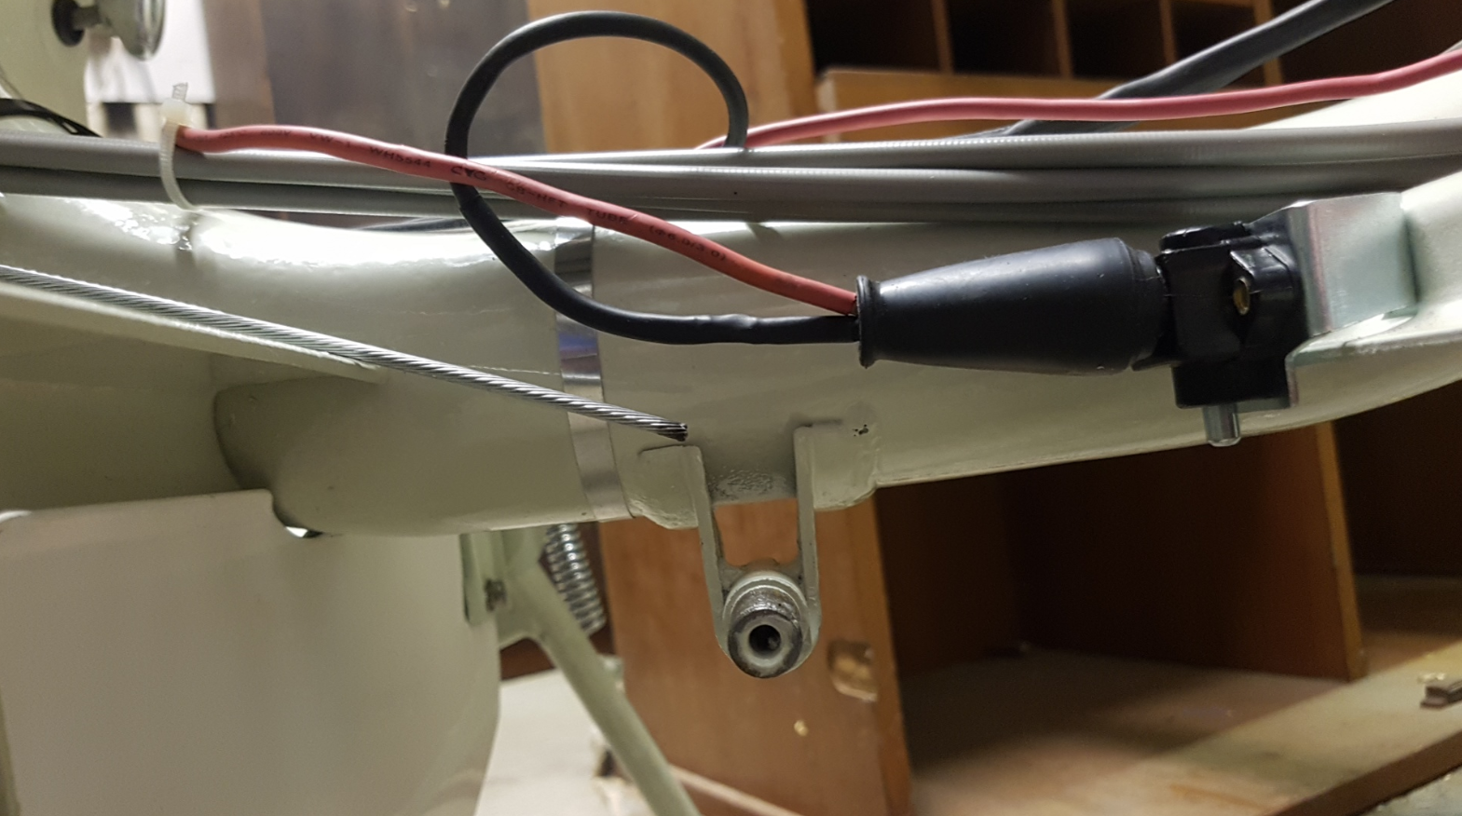
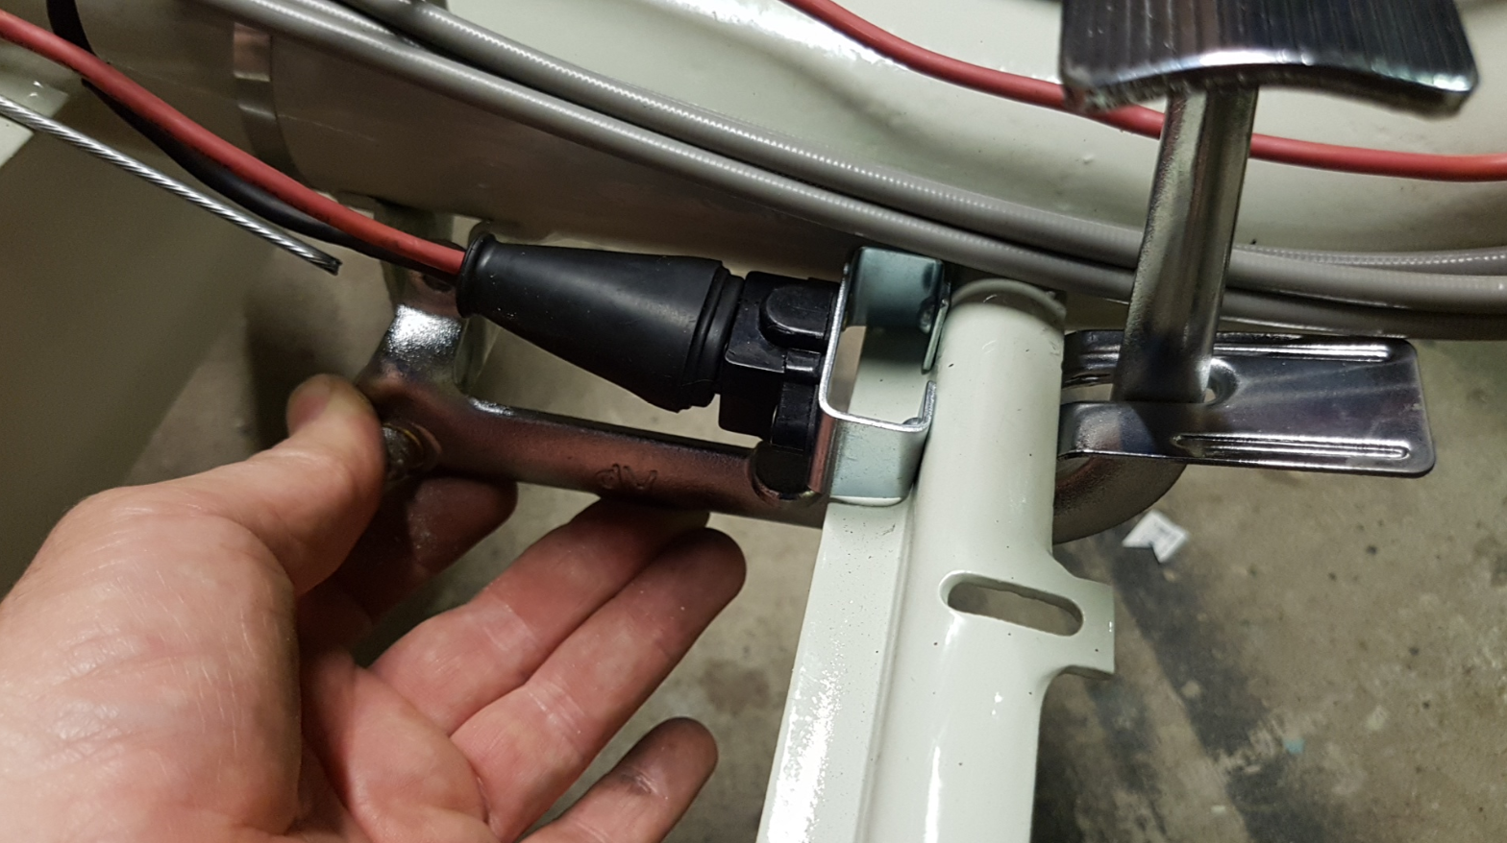
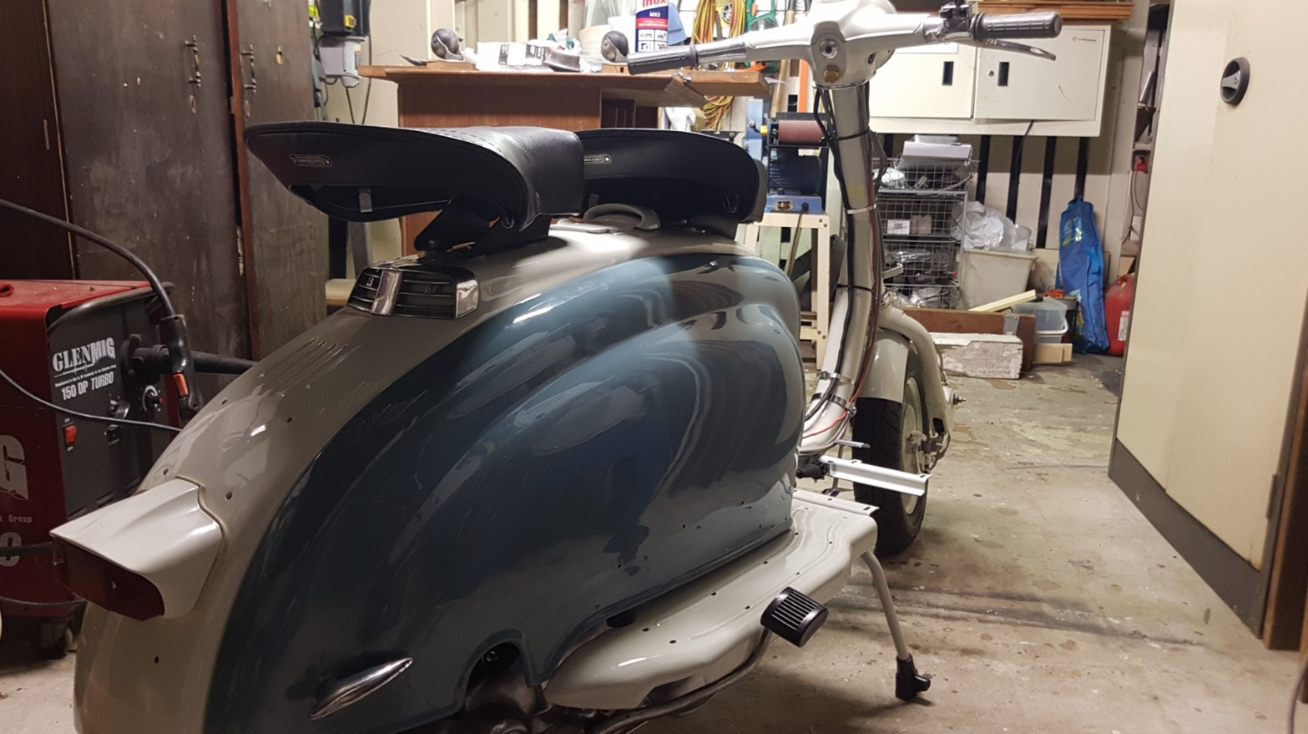
After putting everything back together and checking there was fuel to the carby and spark at the plug, Ian came to pick the scooter up and we took it to his house for a workshop day. No matter what we tried, it just wouldn’t run. It became apparent that I needed to take it home and review where the stator was positioned and check over other timing settings.
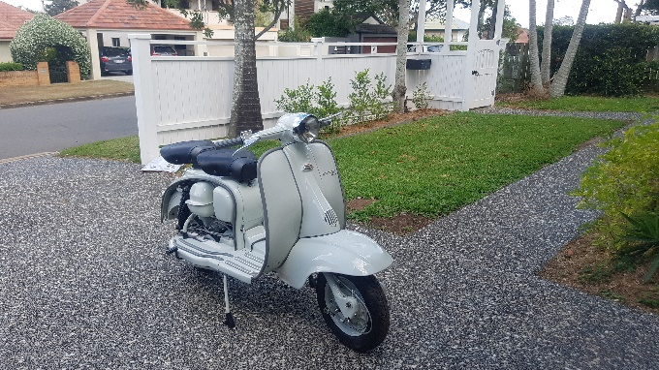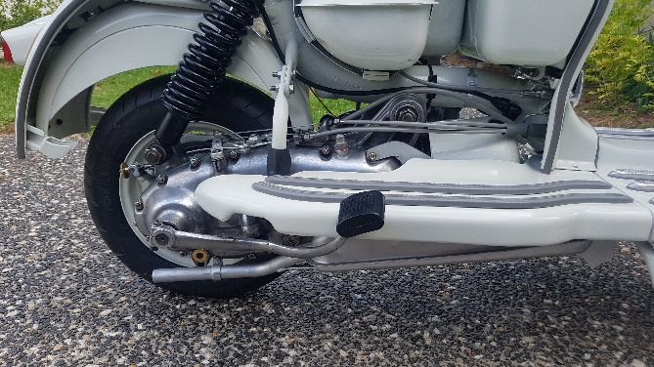
Whilst the spark seemed strong, I dedided to replace the condenser. The points are still in good shape so I kept them. The choke lever was not holding its position so I also replaced that. Then it was a matter of rechecking TDC and the 19 degree before TDC mark I had made on the mag housing and then set the stator position with a timing light. Steve Diffey also told me that he uses cigarete paper to check the timing, by way of feeding the paper into the points and as the flywheel is rotated toward the timing mark, the paper is released. Its on release of the paper where the points start to open and the timing mark can be checked. Its all very fiddly work, but I managed to get the timing set.
I did use the Buzwangle and also checked it with the cigarette paper just to see how close it was. The gauge below was showing 19 degrees but the flywheel rolled back when I took the picture.
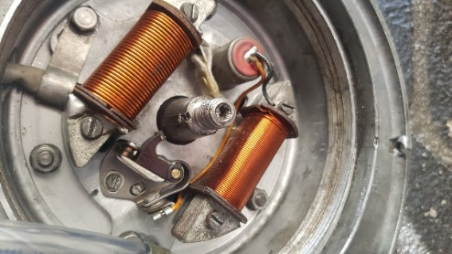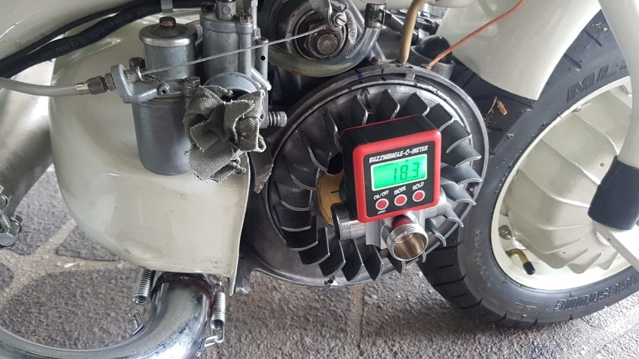
Its now the end of October and I have the scooter running and just about complete and readty for the road. Im waiting on a few more parts from Steve to get it to a point of roadworthiness.
I think ill leave it at that now and look forward to going to some club meets. Thanks to Steve and Ian for all of the help thus far.
